# 

**Development of Auraluxe: A Single Vendor E-commerce Application for Luxury Building Materials**

Md. Moniruzzaman

ID: 22103018

A Practicum in the Partial Fulfillment of the Requirements

for the Award of Bachelor of Computer Science and Engineering (BCSE)



Department of Computer Science and Engineering

College of Engineering and Technology

IUBAT International University of Business Agriculture and Technology

Fall 2025

**Auraluxe: A Single Vendor E-commerce Application for Luxury Building Materials**

Md. Moniruzzaman

A Practicum in the Partial Fulfillment of the Requirements for the Award of Bachelor of Computer Science and Engineering (BCSE)

The practicum has been examined and approved,

_____________________________

Prof. Dr. Utpal Kanti Das

Chairman

_____________________________

Shahinur Alam

Co-supervisor, Coordinator and Assistant Professor

_____________________________

Dipta Mohon Das

Supervisor and Lecturer

Department of Computer Science and Engineering

College of Engineering and Technology

IUBAT International University of Business Agriculture and Technology

Fall 2025

## **Letter of Transmittal**

14 January 2026

The Chair

Practicum Defense Committee

Department of Computer Science and Engineering

IUBAT International University of Business Agriculture and Technology

4 Embankment Drive Road, Sector 10, Uttara Model Town

Dhaka 1230, Bangladesh.

**Subject:** Letter of Transmittal.

Dear Sir,

With due respect, I submit my project report titled **"Auraluxe: A Premium Building Materials E-commerce Platform"**, completed as part of the practicum requirement for the Bachelor of Computer Science and Engineering (BCSE) degree. The project, conducted under the supervision of [Organization Name], focuses on developing a comprehensive single-vendor e-commerce platform that connects customers with premium imported building materials and interior solutions using modern web technologies.

This work provided practical exposure to Next.js, NestJS, PostgreSQL with Prisma ORM, and SSLCommerz payment integration, strengthening my full-stack development and problem-solving skills. I sincerely appreciate your time in reviewing this report and hope it meets the required academic and professional standards.

Yours sincerely,

_________________

Md Moniruzzaman

ID: 22103018

## **Organization’s Certificate**

## **Student’s Declaration**

I hereby declare that the project report entitled **"Auraluxe: A Premium Building Materials E-commerce Platform"** is my original work and has been prepared by me in partial fulfillment of the requirements for the practicum. All sources of information and references used in this report have been properly acknowledged.

I confirm that the contents of this report are original and that no part of this work has been submitted previously for any degree or academic purpose. I have adhered to ethical guidelines in the collection and presentation of data and take full responsibility for the authenticity of this work.

I sincerely hope that this report meets the standards and expectations of the Practicum Defense Committee and respectfully submit it for review and evaluation.

________________

Md. Moniruzzaman

ID: 22103018

## **Supervisor’s Certification**

This is to certify that the project report entitled **"Auraluxe – A Premium Building Materials E-commerce Platform"** has been prepared by **Md. Moniruzzaman**, **ID: 22103018**, in partial fulfillment of the requirements for the practicum.

I have reviewed the report and confirm that the work has been carried out under my supervision. All sources, references, and materials used in this report have been properly cited.

I hereby certify that the report meets the academic standards required by the Department of Computer Science and Engineering, IUBAT, and is suitable for submission and evaluation.

_______________________________

Dipta Mohon Das

Supervisor and Lecturer

Department of Computer Science and Engineering

IUBAT International University of Business Agriculture and Technology

## **Abstract**

This practicum report presents the design and implementation of "**Auraluxe**" a premium building materials e-commerce platform developed to bridge the gap between customers and high-quality imported building materials and interior solutions. The project was conducted during a software development internship at **ATI Limited** to address the inefficiencies and limitations prevalent in traditional showroom-based product discovery and purchasing methods. "**Auraluxe**" utilizes a robust web-based platform built on **Next.js** and **NestJS**, adhering to modern architectural principles to ensure scalability and maintainability. The system integrates **SSLCommerz** payment gateway for secure transaction processing, implements a comprehensive shopping cart system, and provides dynamic content management capabilities for marketing and product showcasing. Key functionalities include user authentication and authorization, advanced product catalog management with category and brand hierarchies, shopping cart operations with persistent state, secure order processing with payment integration, and admin features for content management and project portfolio display. The development followed the Incremental Process Model, enabling the iterative testing and refinement of core modules. The resulting application successfully digitizes the premium building materials marketplace, reducing the time and effort required for customers to discover and purchase quality products while providing a structured platform for business growth. However, the current system is limited by its dependency on continuous internet connectivity and the use of a sandbox environment for payments. Future work will focus on implementing advanced features such as product recommendation systems, real-time inventory synchronization, multi-vendor support, and mobile application development. This project demonstrates the practical application of modern software engineering standards in solving real-world e-commerce challenges in the building materials industry.

## **Acknowledgments**

I would like to take this opportunity to sincerely thank all those who supported and encouraged me throughout the completion of my practicum program and the preparation of the project report entitled "**Auraluxe: A Premium Building Materials E-commerce Platform.**" First and foremost, I express my gratitude to the Almighty for granting me the patience, strength, and perseverance necessary to complete this work. I am also thankful to the **International University of Business, Agriculture and Technology (IUBAT)** for providing an academic environment that fosters both personal and professional growth. I would like to pay special tribute to Late **Prof. Dr. M. Alimullah Miyan**, the Founder of IUBAT, whose visionary leadership opened new avenues for higher education in the non-government sector of Bangladesh. I also extend my sincere appreciation to the honorable Vice-Chancellor, **Prof. Abdur Rab**, for his continued leadership and guidance, which have greatly benefited the institution and its students. My heartfelt thanks go to **Prof. Dr. Utpal Kanti Das**, Professor and Chair, for his valuable advice and encouragement throughout this academic journey. Above all, I am deeply indebted to my supervisor, **Dipta Mohon Das**, **Lecturer**, Department of Computer Science and Engineering, IUBAT, for constant guidance, constructive feedback, and encouragement, which were instrumental in shaping this work.Completing this practicum has enhanced my understanding of the subject matter, strengthened my technical skills, and provided valuable experience in research and report writing. I am truly grateful for the opportunity to work on this project, which has been both academically enriching and professionally rewarding.

**Table of Contents**

**Letter of Transmittal** iii

**Organization’s Certificate** iv

**Student’s Declaration** v

**Supervisor’s Certification** vi

**Abstract** vii

**Acknowledgments** viii

**List of Figures** xiv

**List of Tables** xvi

**Chapter 1.** 1

**Introduction** 1

1.1 Background of the Study 2

1.2 Methodology 4

1.2.1 Primary Sources 4

1.2.2 Secondary Sources 4

1.3 Objectives 6

1.3.1 Broad Objective 6

1.3.2 Specific Objectives 6

1.4 Process Model 7

1.4.1 Characteristics of Incremental Process Model: 8

1.4.2 Reasons for Choosing the Incremental Process Model 8

1.5 Feasibility Study 10

1.5.1 Technical Feasibility 10

1.5.2 Economic Feasibility 11

1.5.3 Operational Feasibility 11

1.6 Structure of the Report 12

**Chapter 2.** 13

**Organizational Overview** 13

2.1 Organization Vision 14

2.2 Organization Mission 14

2.3 Organization Services 14

2.4 Organizational Structure 15

2.5 My Position in this Organization 15

2.6 Address of the Organization 15

**Chapter 3.** 16

**Requirement Engineering** 16

3.1 Requirement Analysis 17

3.2 Requirement Engineering 17

3.2.1 User and System Requirements 17

3.2.2 Functional Requirements 19

3.2.3 Non-Functional Requirements 20

3.3 Use Case Diagram of the System 21

**Chapter 4.** 23

**Analysis** 23

4.1 Software Analysis Pattern 24

4.2 Activity Diagrams 25

4.2.1 Activity Diagram for User Registration 26

4.2.2 Activity Diagram of Admin 27

4.2.3 Activity Diagram of product purchase 28

4.3 Swim-lane Diagrams 29

4.3.1 Swim-lane Diagram for User Registration 29

4.3.2 Swim-lane Diagram for Admin Dashboard 30

4.3.3 Swim-lane Diagram for Product Purchase 31

4.4 Sequence Diagrams 31

4.4.1 Sequence Diagram for Registration 32

4.4.2 Sequence Diagram for Admin Dashboard 33

4.4.3 Sequence Diagram for Product Purchase 34

4.5 Class Diagram of the Auraluxe System 35

**Chapter 5.** 37

**Project Management** 37

5.1 Risk Identification 38

5.2 Risk Analysis 39

5.3 Risk Planning 39

5.4 The RMMM Plan 40

**Chapter 6.** 43

**Project Planning** 43

Chapter 6: Project Planning 44

6.1 System Project Estimation 44

6.2 Function-Oriented Metrics 45

6.3 Identifying Complexity 45

6.3.1 Identifying Complexity of Transaction Functions 45

6.3.2 Identifying Complexity of Data Functions 46

6.3.3 Unadjusted Function Point Contribution 46

6.3.4 Unadjusted Function Point Contribution 47

6.3.5 Performance and Environmental Impact 48

6.3.6 Counting Adjusted Function Point 48

6.4 Project Scheduling (Gantt Chart) 49

6.5 Accounts Table 51

6.5.1 Personnel Cost 51

6.5.2 Expected Hardware Cost 51

6.5.3 Expected Software Cost 52

6.5.4 Expected Other Cost 52

6.6 Clarification of Academic vs. Industry Estimates 53

**Chapter 7.** 54

**Designing** 54

7.1 Interface Design 55

7.2 Data Flow Diagram (DFD) 67

7.2.1 Context-Level DFD (Level 0) 67

7.2.2 DFD Level 1 69

7.2.3 DFD Level 2 70

7.3 Database Design 73

7.3.1 Normalization of Data Fields 73

7.3.2 Entity Relationship (ER) Model 74

7.3.3 Database Table Structure 76

7.4 ER Diagram for Auraluxe System 83

**Chapter 8.** 85

**System Quality and Testing** 85

8.1 System Quality Management 86

8.1.1 Software Quality Management Process 86

8.1.2 Software Test Cases 87

**Chapter 9.** 92

**Ethical Consideration** 92

9.1 Ethical Considerations in the Software Development Process 93

9.2 Sustainability in the Software Development Process 95

**Chapter 10.** 98

**Conclusion** 98

10.1 Brief Overview of the Project 99

10.2 Proposed System Benefits 99

10.3 Limitations of the Project 100

10.4 Practicum and Its Value 100

10.5 Future Plan 101

**References** 103

## **List of Figures**

Figure 3.1: Use Case Diagram 21

Figure 4.1: Clean Code Architecture 24

Figure 4.2: Activity Diagram for User Registration 26

Figure 4.3: Activity Diagram of Admin 27

Figure 4.4: Activity Diagram of product purchase 28

Figure 4.5: Swim-lane Diagram for User Registration 29

Figure 4.6: Swim-lane Diagram for Admin Dashboard 30

Figure 4.7: Swim-lane Diagram for Product Purchase 31

Figure 4.8: Sequence Diagram for Registration 32

Figure 4.9: Sequence Diagram for Admin Dashboard 33

Figure 4.10: Sequence Diagram for Product Purchase 34

Figure 4.11: Class Diagram of Auraluxe 36

Figure 6.1: Project Schedule Gantt Chart 50

Figure 7.1: Hero Section of Home Page 56

Figure 7.2: Our Product Section of Home Page 56

Figure 7.3: Our Featured Section of Home Page 57

Figure 7.4: Trusted Partner Section 57

Figure 7.5: Product Page 58

Figure 7.6: Product Detail Page 59

Figure 7.7: News and Update Page 60

Figure 7.8: Contact Us Page 61

Figure 7.9: Project Page 62

Figure 7.10: Project Detail Page 63

Figure 7.11: Key Brands Page 64

Figure 7.12: Admin Dashboard Home Featured Product page 65

Figure 7.13: Admin Dashboard Home Featured Add Form 65

Figure 7.14: Admin Dashboard Home Featured Update Form 66

Figure 7.15: Admin Dashboard Product Delete Warning 66

Figure 7.27: Context Level DFD (Level 0) 67

Figure 7.28: Level 1 DFD 69

Figure 7.29: DFD Level 2 Process 1 - User Registration 70

Figure 7.30: DFD Level 2 Process 2 - Product Browsing 71

Figure 7.32: DFD Level 2 Process 3.1 - Add to Cart 71

Figure 7.34: DFD Level 2 Process 4.1 - Order 72

Figure 7.35: DFD Level 2 Process 5 - Payment Processing 72

Figure 7.35: DFD Level 2 Process 6 - Product Management 73

Figure 7.37: ER Diagram of Auraluxe System 84

Figure 9.1: Sustainability Considerations in Software Development 97

## **List of Tables**

Table 5.1: Risk Identification Table 38

Table 5.2: Risk Analysis Table 39

Table 5.3: Risk Planning Table 39

Table 5.4: Risk Mitigation, Monitoring, and Management Table 41

Table 6.1: Unadjusted Function Point Contribution (Transaction Function) 46

Table 6.2: Unadjusted Function Point Contribution (Data Function) 47

Table 6.3: Performance and Environmental Impact (GSC) 48

Table 6.4: Personnel Cost 51

Table 6.5: Expected Hardware Cost 51

Table 6.6: Expected Software Cost 52

Table 6.7: Expected Other Cost 52

Table 7.1: User Table 76

Table 7.2: Product Table 76

Table 7.3: category Table 77

Table 7.4: Brand Table 77

Table 7.4: brandType Table 78

Table 7.5: Cart Table 78

Table 7.6: CartItem Table 79

Table 7.7: Project Type Table 79

Table 7.8: Project Table 79

Table 7.9: material Table 80

Table 7.10: homeBanner Table 81

Table 7.11: homeOurFeatured Table 81

Table 7.12: homeOurProduct Table 82

Table 7.13: ourFeaturedProduct Table 82

Table 7.14: keyBrands Table 83

Table 8.1: Test Cases for the System 87

## **Chapter 1.**

## **Introduction**

The digital transformation of the building materials and interior solutions industry has created unprecedented opportunities for businesses to reach wider audiences and streamline their operations. Auraluxe represents a comprehensive e-commerce platform developed to address the growing demand for premium building materials and interior solutions in the digital marketplace. This practicum project was undertaken at Tilottoma, a leading premium building materials and interior solutions provider in Bangladesh, where the practical application of modern web technologies was employed to create a robust, scalable, and user-friendly e-commerce solution.

The development of Auraluxe encompasses the complete lifecycle of a modern web application, from requirement analysis and system design to implementation and testing. This project demonstrates the integration of cutting-edge technologies including Next.js, NestJS, PostgreSQL, and Prisma ORM to create a single-vendor e-commerce platform that serves both administrative and customer needs effectively. The platform facilitates seamless product management, inventory control, order processing, and secure payment transactions through SSLCommerz integration.

This practicum experience provided invaluable hands-on exposure to professional software development practices, agile methodologies, and real-world problem-solving in the context of e-commerce solutions. The project not only fulfills the academic requirements of the Bachelor of Computer Science and Engineering program but also contributes a functional business solution that addresses genuine market needs in the premium building materials sector.

#### 1.1 Background of the Study

The building materials and interior solutions industry in Bangladesh has experienced significant growth over the past decade, driven by rapid urbanization, infrastructure development, and increasing consumer awareness about quality construction materials. Traditional brick-and-mortar showrooms, while effective, present limitations in terms of accessibility, product information dissemination, and customer convenience. The COVID-19 pandemic further accelerated the need for digital transformation in this sector, as customers increasingly prefer online browsing and purchasing options.

Tilottoma, established in 1980, has been at the forefront of providing premium imported luxury building materials and interior solutions in Bangladesh. With over four decades of experience, the organization recognized the imperative need to establish a strong digital presence to complement its physical operations and serve the evolving needs of modern customers. The absence of a comprehensive e-commerce platform limited the company's ability to showcase its extensive product catalog, reach geographically dispersed customers, and provide detailed product information that aids informed purchasing decisions.

The e-commerce sector in Bangladesh has witnessed exponential growth, with the digital payment infrastructure improving significantly through services like SSLCommerz, bKash, and Nagad. This technological advancement has made online transactions more secure and accessible to a broader demographic. However, the building materials industry has been slower to adopt comprehensive digital solutions compared to other retail sectors, presenting both a challenge and an opportunity.

This practicum addresses the critical need for a sophisticated, feature-rich e-commerce platform specifically tailored for the premium building materials sector. The platform must handle complex product categorizations, detailed specifications, brand management, project portfolios, and secure payment processing while maintaining an intuitive user experience. The development of Auraluxe represents a practical application of modern software engineering principles to solve real-world business challenges, bridging the gap between traditional business operations and contemporary digital commerce requirements.

Furthermore, this practicum provides an opportunity to explore the full-stack development ecosystem using industry-standard technologies such as the MERN stack principles adapted with Next.js and NestJS, demonstrating proficiency in both frontend and backend development, database design, API architecture, and payment gateway integration. The project serves as a comprehensive learning experience that encompasses system analysis, software design patterns, security implementation, and deployment strategies essential for professional software development careers.

#### 1.2 Methodology

The development of the Auraluxe e-commerce platform employed a systematic approach utilizing both primary and secondary data sources to ensure comprehensive understanding of requirements, effective implementation, and successful project delivery. The methodology encompassed various research techniques, development practices, and validation processes.

##### 1.2.1 Primary Sources

The primary data sources provided firsthand information and direct insights essential for the project development:

* **Stakeholder Interviews**: Conducted detailed discussions with Tilottoma management, sales personnel, and warehouse staff to understand business processes, product management workflows, and customer interaction patterns.
* **Customer Surveys**: Gathered feedback from existing customers regarding their preferences for online shopping features, payment methods, and product information requirements.
* **Requirement Gathering Sessions**: Organized multiple sessions with project supervisors and organizational representatives to define functional and non-functional requirements clearly.
* **Direct Observation**: Observed current manual processes for inventory management, order processing, and customer service operations to identify pain points and automation opportunities.
* **User Testing**: Conducted usability testing sessions with potential end-users to validate interface design, navigation flow, and feature accessibility.
* **Performance Monitoring**: Implemented analytics and monitoring tools to gather real-time data on application performance, user behavior, and system bottlenecks.
* **Supervisor Feedback**: Regular consultations with academic and organizational supervisors to ensure alignment with project objectives and industry standards.

##### 1.2.2 Secondary Sources

Secondary data sources supplemented primary research with theoretical foundations and industry best practices:

* **Technical Documentation**: Extensive review of official documentation for Next.js, NestJS, Prisma ORM, PostgreSQL, React Hook Form, TanStack Query, and SSLCommerz to understand capabilities and implementation patterns.
* **Academic Literature**: Studied research papers and academic publications on e-commerce systems, software engineering methodologies, database design principles, and user experience optimization.
* **Industry Reports**: Analyzed market research reports on e-commerce trends in Bangladesh, building materials industry growth patterns, and digital payment adoption statistics.
* **Case Studies**: Examined successful e-commerce implementations in similar industries to identify best practices, common pitfalls, and innovative features.
* **Online Resources**: Utilized Stack Overflow, GitHub repositories, Medium articles, and developer communities for problem-solving, code examples, and architectural patterns.
* **E-commerce Standards**: Reviewed industry standards for online payment security (PCI DSS), data protection, accessibility guidelines (WCAG), and performance benchmarks.
* **Competitive Analysis**: Studied existing e-commerce platforms in the building materials sector to identify market gaps, feature expectations, and differentiation opportunities.
* **Technology Blogs**: Followed technology blogs and newsletters to stay updated on emerging trends, security vulnerabilities, and framework updates.

#### 1.3 Objectives

The objectives of the Auraluxe e-commerce platform development have been categorized into broad and specific objectives to provide clear direction and measurable outcomes for the practicum work.

##### 1.3.1 Broad Objective

To design, develop, and deploy a comprehensive single-vendor e-commerce platform for premium building materials and interior solutions that enhances customer experience, streamlines administrative operations, and facilitates secure online transactions while demonstrating proficiency in full-stack web development using modern technologies.

##### 1.3.2 Specific Objectives

The specific objectives that guide the development and implementation of the Auraluxe platform are:

* **Develop a robust product management system** that enables administrators to efficiently create, update, and organize products with comprehensive details including specifications, pricing, images, categories, and brand associations.
* **Implement a user-friendly customer interface** that allows customers to browse products seamlessly, search and filter based on multiple criteria, view detailed product information, and access project portfolios showcasing real-world applications.
* **Create a secure authentication and authorization system** that manages user registration, login, password recovery, and role-based access control to ensure data security and appropriate feature access for different user types.
* **Build an efficient shopping cart and order management system** that enables customers to add products to cart, modify quantities, proceed through checkout, and track order status while allowing administrators to manage orders and update fulfillment stages.
* **Integrate SSLCommerz payment gateway** to provide secure, reliable, and diverse payment options including credit/debit cards, mobile banking, and internet banking, ensuring transaction security and customer confidence.
* **Design and implement a scalable database schema** using PostgreSQL and Prisma ORM that maintains data integrity, supports complex relationships between entities, and optimizes query performance for enhanced application responsiveness.
* **Develop RESTful APIs using NestJS** that follow industry best practices, implement proper error handling, validation, and documentation to ensure maintainable and extensible backend architecture.
* **Implement responsive frontend design** using Next.js and TypeScript that provides optimal viewing experience across devices, implements server-side rendering for improved performance and SEO, and utilizes modern state management techniques.
* **Establish comprehensive testing and quality assurance procedures** including form validation using Zod, API testing, and user acceptance testing to ensure reliability, functionality, and user satisfaction.
* **Deploy the application in a production environment** with proper configuration, security measures, monitoring, and documentation to demonstrate readiness for real-world usage.

#### 1.4 Process Model

The development of the Auraluxe e-commerce platform follows the **Incremental Process Model**. This approach was selected to accommodate the complex nature of e-commerce systems, enable progressive delivery of functional modules, and ensure systematic validation of each component before proceeding to subsequent development phases.

The Incremental Process Model is a software development methodology where the system is designed, implemented, and tested incrementally until the complete product is achieved. Unlike the waterfall model that delivers the entire system at once, the incremental model delivers the system in parts, called increments. Each increment represents a portion of the system's functionality, and when integrated, these increments form the complete application.

In the context of Auraluxe development, the system was divided into multiple increments, each representing distinct functional modules such as user authentication, product catalog management, shopping cart functionality, order processing, payment integration, and content management. Each increment went through the complete software development lifecycle including requirements analysis, design, implementation, testing, and deployment before the next increment began.

##### ****1.4.1 Characteristics of Incremental Process Model:****

* **Modular Development Approach**: The entire e-commerce platform was decomposed into logical functional modules (authentication module, product management module, cart module, order module, payment module, and content management module), each developed as a separate increment.
* **Sequential Increment Delivery**: Development followed a planned sequence starting with foundational features (user authentication and database setup) progressing to core business logic (product catalog and categories) and culminating in advanced features (payment gateway integration and order tracking).
* **Early Functional Delivery**: The first increment delivered a minimal viable product with basic user authentication and product listing capabilities, providing early validation of the core concept and allowing stakeholder feedback on fundamental functionality.
* **Integration After Each Increment**: Upon completion of each increment, it was integrated with previously developed increments, ensuring compatibility and smooth interaction between different modules of the system.
* **Independent Testing Phases**: Each increment underwent rigorous unit testing, integration testing, and validation before being accepted, ensuring quality and functionality at every stage of development.
* **Progressive Requirement Refinement**: Requirements for subsequent increments could be refined based on insights gained from earlier increments, allowing for realistic planning and expectation management.

##### 1.4.2 Reasons for Choosing the Incremental Process Model

* **Risk Reduction**: By developing and testing the system in small increments, technical and functional risks are identified and mitigated early in the development process. If an increment fails, only that specific module needs revision rather than the entire system.
* **Early Functionality Demonstration**: Delivering working increments early in the development cycle allows stakeholders to see tangible progress, validate requirements, and provide feedback when changes are still relatively easy to implement.
* **Easier Testing and Debugging**: Smaller increments are easier to test comprehensively. Isolating bugs and issues is more straightforward when working with focused functional modules rather than the entire complex system.
* **Flexible Priority Management**: Critical features can be developed in early increments ensuring that if time or resource constraints arise, the system will still have its most essential functionality operational.
* **Better Resource Allocation**: Development resources can be allocated efficiently across increments, with team members focusing on specific modules according to their expertise and project timeline requirements.
* **Stakeholder Engagement**: Regular delivery of working increments maintains stakeholder interest and confidence in the project, demonstrating continuous progress and value delivery throughout the development period.
* **Manageable Complexity**: Breaking down the complex e-commerce system into manageable increments makes the overall development process less overwhelming and more organized, facilitating better project management and progress tracking.
* **Accommodation of Learning Curve**: As this is a practicum project, the incremental approach allows for learning and skill development in stages, with each increment building upon knowledge and experience gained from previous ones.
* **Parallel Development Opportunities**: Once the architectural foundation is established in early increments, certain independent modules can be developed in parallel, optimizing the development timeline without compromising integration integrity.
* **Easier Maintenance and Enhancement**: The modular nature of incremental development results in a well-structured codebase where individual modules can be maintained, updated, or enhanced independently without affecting the entire system.

#### 1.5 Feasibility Study

The feasibility study for the Auraluxe e-commerce platform was conducted to assess the viability of the project from technical, economic, and operational perspectives. This comprehensive analysis ensured that the project objectives could be achieved within available resources, constraints, and organizational context.

##### 1.5.1 Technical Feasibility

The Auraluxe platform is technically feasible based on the following considerations. All required technologies including Next.js, NestJS, PostgreSQL, Prisma ORM, TypeScript, React Hook Form, Zod, TanStack Query, Axios, and TanStack Table are open-source, well-documented, and widely supported by active developer communities with proven track records in production environments. The development team possesses adequate knowledge and skills in JavaScript/TypeScript, React ecosystem, Node.js backend development, database design, and RESTful API architecture, with any knowledge gaps addressable through available documentation and online resources. The project requires standard web hosting infrastructure supporting Node.js applications and PostgreSQL databases, readily available through cost-effective cloud platforms such as Vercel for Next.js frontend and Railway or Heroku for NestJS backend with managed PostgreSQL services. SSLCommerz provides comprehensive API documentation and sandbox environments specifically designed for the Bangladesh market with established integration patterns for Node.js applications. The chosen technology stack supports both horizontal and vertical scaling, with PostgreSQL handling large datasets efficiently, Next.js providing optimized rendering strategies, and NestJS architecture supporting future microservices expansion. Modern development tools including Visual Studio Code, Git, GitHub, Postman, and Prisma Studio are freely available and sufficient for all project requirements. The technologies selected are capable of meeting performance requirements including page load times under 3 seconds, API response times under 1 second, and support for concurrent users as specified in system requirements, while providing built-in security features including JWT authentication, password hashing, input validation, SQL injection prevention through Prisma ORM, and HTTPS encryption for data transmission.

##### 1.5.2 Economic Feasibility

The Auraluxe platform is economically feasible with minimal financial investment. The project primarily requires time and effort rather than substantial financial investment, as all core technologies are open-source and free to use, eliminating licensing costs, with development conducted as part of the academic practicum under university and organizational supervision. Cloud hosting services offer generous free tiers and student programs suitable for development and initial deployment, with Vercel providing free hosting for Next.js applications and services like Railway or Render offering free PostgreSQL databases, resulting in estimated production-level hosting costs of only $10-30 monthly. SSLCommerz operates on a transaction-based fee model charging 2-3% per successful transaction with no upfront setup fees or monthly subscriptions, making it economically viable with pay-as-you-grow pricing. Ongoing maintenance costs are minimal as the platform uses stable, well-maintained open-source technologies where updates and security patches are typically free and easily applied. For the host organization, the platform provides significant value by expanding market reach, reducing manual operational overhead, enabling 24/7 product showcase, and facilitating direct customer engagement, with the digital platform potentially increasing sales opportunities without proportional increases in operational costs. The benefits of digital presence, improved customer experience, streamlined operations, and competitive advantage far outweigh the minimal development and operational costs, making the project highly economically feasible.

##### 1.5.3 Operational Feasibility

The Auraluxe platform is operationally feasible as it seamlessly integrates with Tilottoma's existing business workflows without requiring major operational overhauls. The administrative interface is designed to be intuitive and user-friendly, requiring minimal training for staff members to manage products, process orders, and monitor inventory effectively. The platform complements rather than replaces current operations, allowing the organization to maintain their established processes while benefiting from digital automation and improved efficiency. The host organization has demonstrated strong commitment to this digital transformation initiative by providing necessary support, resources, and stakeholder availability throughout the development process. Customer acceptance is expected to be high as the platform addresses genuine needs for convenient online access to product information, detailed specifications, and secure payment options. The well-structured codebase following industry best practices ensures long-term maintainability, and the modular architecture supports future enhancements and scalability as business needs evolve, making the platform a sustainable operational asset for the organization.

##### 1.6 Structure of the Report

The report is structured systematically into four chapters to provide a comprehensive overview of the Auraluxe e-commerce platform development project. Following this Introduction, Chapter 2 provides an in-depth overview of Tilottoma, the host organization, including its vision, mission, services, organizational structure, and the specific role undertaken during the practicum period. Chapter 3 presents the Methods and System Implementation, detailing the requirement engineering process, system architecture and design, database schema development, frontend and backend implementation strategies, API development, payment gateway integration, security measures, and comprehensive testing methodologies employed throughout the development lifecycle. Finally, Chapter 4 concludes the report with a detailed discussion of project outcomes, challenges encountered and solutions implemented, lessons learned, achievement of objectives, system limitations, and recommendations for future enhancements and scalability considerations.

## **Chapter 2.**

## **Organizational Overview**

ATI Limited is a leading software development company that has been delivering innovative technology solutions since 1998. Established with a vision to transform businesses through cutting-edge software development, ATI Limited has grown into a trusted partner for organizations seeking robust, scalable, and efficient digital solutions. The company specializes in custom software development, web application development, enterprise resource planning (ERP) systems, and mobile application development, serving clients across multiple industries and geographical locations.

#### 2.1 Organization Vision

To be the most trusted technology partner for businesses worldwide, delivering innovative software solutions that drive digital transformation and sustainable growth.

#### 2.2 Organization Mission

ATI Limited is committed to providing end-to-end custom software solutions that streamline operations, enhance productivity, and drive innovation. The company focuses on understanding client requirements deeply and delivering scalable, high-quality software solutions from development to deployment. Through continuous innovation and a client-centric approach, ATI Limited aims to help businesses leverage technology to achieve their strategic objectives and maintain competitive advantage in their respective industries.

#### 2.3 Organization Services

ATI Limited provides a range of services, including:

1. **Custom Software Development:** Development of software solutions designed for specific business requirements across industries.
2. **Enterprise Resource Planning (ERP) Solutions:** Implementation of ERP systems to integrate operations, increase efficiency, and support decision-making.
3. **Mobile Application Development:** Recognizing the growing importance of mobile technology, ATI Limited develops innovative mobile applications for iOS and Android platforms
4. **E-commerce Platform Development:** Creation of e-commerce websites and mobile applications that support online transactions and business growth.

#### 2.4 Organizational Structure

ATI Limited operates with a hierarchical organizational structure designed to ensure effective project management, quality assurance, and client satisfaction. The company is led by experienced management professionals who oversee various departments including Software Development, Web Development, Mobile Development, Quality Assurance, Project Management, and Client Relations. Each department is headed by senior technical leads who manage teams of developers, designers, and analysts. The organizational structure promotes collaboration, knowledge sharing, and adherence to software engineering best practices.

#### 2.5 My Position in this Organization

During my practicum period at ATI Limited, I am working as a **Junior Frontend Developer** within the Web Development department. In this role, I am responsible for developing and implementing the Auraluxe e-commerce platform, working under the supervision of senior developers and the project lead.

#### 2.6 Address of the Organization

ATI Centre, House-07

Gareeb-E-Nawaz Avenue, Sector-11

Uttara, Dhaka-1230, Bangladesh

## **Chapter 3.**

## **Requirement Engineering**

#### 3.1 Requirement Analysis

Requirement analysis is a pivotal phase that defines the scope, functionality, and user experience of **Auraluxe**. The analysis focused on identifying the core problem in the building material industry: the lack of a centralized, digital platform where customers can view imported luxury materials and real-world project inspirations simultaneously.

Currently, customers often have to visit physical showrooms to see premium materials or understand how they look in a finished project. **Auraluxe** addresses this by offering a "Single Vendor" e-commerce solution where users can browse materials (stones, tiles, fittings), view completed architectural projects for inspiration, and order products directly. The analysis of the reference site (Tilottoma) highlighted the need for features like "Project Showcases," "Brand-wise filtering," and "Material Categorization" to enhance the digital purchasing experience.

#### 3.2 Requirement Engineering

The requirements were categorized into User, System, Functional, and Non-Functional requirements to ensure a holistic definition of the system.

##### 3.2.1 User and System Requirements

This section maps high-level user needs to specific, testable system requirements.

**1. Authentication and Account Management**

* 1. The system shall provide a secure registration system allowing customers to create accounts using email and password.
  2. The system shall enforce role-based access control (RBAC) covering **User** and **Admin** roles, as defined in the database schema (UserRole enum).
  3. The system shall ensure secure login functionality using **NestJS** backend authentication strategies (JWT).
  4. The system shall allow users to manage their profiles, including viewing their order history and updating personal details.

**2. Product and Project Discovery**

* 1. The system shall allow users to browse products filtered by Category, Brand, or Material type.
  2. The system shall implement a Project Showcase section where users can view architectural projects (including Project Name, Location, Architects, and Images) to understand how materials are applied in real life.
  3. The system shall provide a search bar allowing keyword-based queries for products and brands.
  4. The system shall display detailed product cards including Product Name, Price, Specifications, Key Features, and Stock Quantity.

1. **Cart and Order Management**
   1. The system shall enable users to add products to a Cart, supporting multiple items with adjustable quantities.
   2. The system shall validate stock availability (quantity in Product model) before allowing an item to be added to the cart.
   3. The system shall allow users to proceed to checkout and generate an order with a unique ID.
   4. The system shall implement a CartItem model to track unit prices and quantities for each session.

**4. Payments and Transactions**

* 1. The system shall integrate **SSLCommerz** for handling secure online payments.
  2. The system shall ensure transactional integrity by updating the order status only upon successful payment confirmation.
  3. The system shall maintain a transaction history accessible to both the User (My Orders) and the Admin.

**5. Administration and Content Management**

**5.1** The Admin shall have a dashboard to view total users, active orders, and inventory status.

**5.2** The system shall provide **CRUD (Create, Read, Update, Delete)** capabilities for the Admin to manage:

* **Products:** Uploading images, setting prices, and linking to Brands/Categories.
* **Projects:** Managing portfolio entries with details like Client, Architects, and Location.
* **Home Banners:** Managing the dynamic slider images on the frontend (homeBanner model).

**5.3** The Admin shall be able to manage **Brands** and **Brand Types**, including uploading logos and descriptions.

##### 3.2.2 Functional Requirements

Functional requirements define the specific behaviors of the Auraluxe system.

**User Functions:**

* **Registration/Login:** Secure entry using Zod-validated forms.
* **Browse Inventory:** View products using TanStack Table or Grid views.
* **Manage Cart:** Add/Remove items and view total cost calculations.
* **Place Order:** Complete purchases via SSLCommerz gateway.
* **View Projects:** Access the "Inspiration" section to see Project and Material relations.

**Admin Functions:**

* **Inventory Management:** Monitor quantity levels and update stock.
* **Order Fulfillment:** View incoming orders and update their status (e.g., Pending to Delivered).
* **Content Management:** Update "Our Featured" and "Home Banner" sections to keep the site fresh.
* **Data Entry:** Add new Materials, Project Types, and Key Brands into the database.

##### 3.2.3 Non-Functional Requirements

Non-functional requirements define system quality and performance standards.

1. **Security:** The system shall ensure secure handling of user data by hashing passwords using **bcrypt** and managing sessions via **JSON Web Tokens (JWT)** strategies in NestJS. Role-based authorization (User, Admin, Vendor) shall restrict access to sensitive routes, and all form inputs shall be validated on both client and server sides using **Zod** schemas to prevent SQL injection and XSS attacks.
2. **Performance:** The system shall deliver high-speed performance by leveraging **Next.js Server-Side Rendering (SSR)** to ensure initial page loads occur under 2 seconds. API data fetching shall be optimized using **TanStack Query** to cache server states and minimize redundant network requests, while high-resolution product images shall be optimized automatically using the Next.js Image component.
3. **Scalability:** The system shall be designed to support future business growth by utilizing the modular architecture of **NestJS**, allowing independent scaling of services. The **PostgreSQL** database shall be structured with **Prisma ORM**, ensuring that complex relationships between products, brands, and projects remain performant as the dataset grows.
4. **Reliability and Availability:** The platform shall ensure data integrity during critical operations, such as inventory deduction and payment processing, by adhering to **ACID principles** within PostgreSQL transactions. The system shall handle API failures gracefully using global exception filters to prevent application crashes and ensure continuous availability.
5. **Usability:** The user interface shall be fully responsive across mobile, tablet, and desktop devices, implemented using **Tailwind CSS**. The system shall provide immediate visual feedback for user interactions (such as "Added to Cart" or form errors) to ensure a seamless, premium shopping experience consistent with a luxury brand.
6. **Maintainability:** The system shall be developed using a strictly typed **TypeScript** codebase to reduce runtime errors and improve code readability. The backend structure shall separate concerns into Controllers, Services, and Repositories, while the database schema shall be centrally managed and documented via the **Prisma Schema** file.

#### 3.3 Use Case Diagram of the System

Figure 3.1: Use Case Diagram

* **Actor: User** -> Uses cases: Register, Login, Search Product, View Project Showcase, Add to Cart, Pay via SSLCommerz.
* **Actor: Admin** -> Uses cases: Login, Manage Products, Manage Projects, Manage Brands, View Orders, Update Home Banners.

## **Chapter 4.**

## **Analysis**

System analysis is the process of breaking down the Auraluxe e-commerce platform into its component parts to understand their relationships and interactions. In this phase, the requirements gathered in Chapter 3 were transformed into visual models and logical structures. The analysis focuses on understanding the flow of data between the Next.js frontend, the NestJS backend, and the PostgreSQL database, ensuring that the architecture effectively supports both luxury product sales and the unique "Project Inspiration" showcase features.

#### 4.1 Software Analysis Pattern

We adopted a Modular Layered Architecture (aligned with Clean Architecture principles) for Auraluxe using the NestJS framework. This pattern organizes code into distinct modules and layers, ensuring that the core business logic remains independent of external frameworks or database specifics. This separation of concerns promotes the longevity, testability, and maintainability of the codebase.

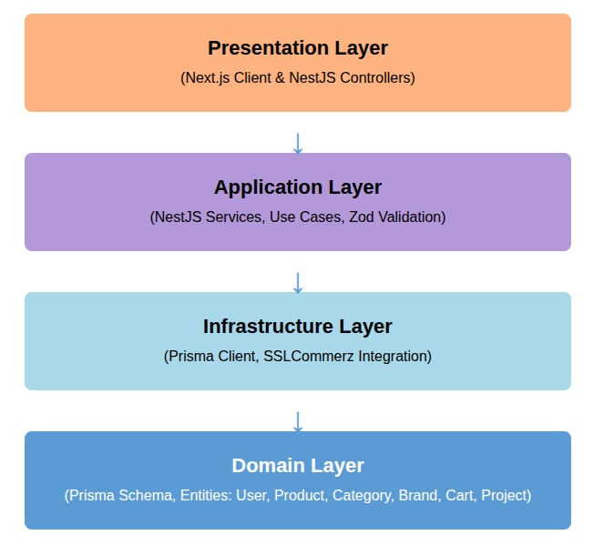

Figure 4.1: Clean Code Architecture

* **Domain Layer (Entities):** The core of the system containing the Enterprise Logic and Data Models (User, Product, Brand, Project). In our system, these are defined via the Prisma Schema, serving as the single source of truth for our data structure without external dependencies.
* **Application Layer (Services):** Contains the business rules and Use Cases. It depends on the Domain layer and orchestrates the flow of data. This layer (implemented as NestJS Services) handles logic such as stock verification, Zod validation, and order processing before interacting with the database.
* **Infrastructure Layer:** Implements the interfaces and data access mechanisms required by the Application layer. In Auraluxe, this includes the Prisma Client (for PostgreSQL access) and external integrations like the SSLCommerz payment gateway. It depends on the Application layer to know what data to fetch or save.
* **Presentation Layer (Controllers & Client):** The entry point for the application. It consists of NestJS Controllers (which handle incoming API requests) and the Next.js Frontend (which presents the UI to the user). This layer depends on the Application layer to retrieve data and return responses to the client.

#### 4.2 Activity Diagrams

Activity diagrams illustrate the dynamic nature of the system by modeling the flow of control from activity to activity.

##### 4.2.1 Activity Diagram for User Registration

Figure 4.2: Activity Diagram for User Registration

##### 4.2.2 Activity Diagram of Admin

Figure 4.3: Activity Diagram of Admin

##### 4.2.3 Activity Diagram of product purchase

Figure 4.4: Activity Diagram of product purchase

#### 4.3 Swim-lane Diagrams

Swim-lane diagrams delineate specific responsibilities within a process, clarifying the interaction between the User, System, Database, and External Services.

##### 4.3.1 Swim-lane Diagram for User Registration

Figure 4.5: Swim-lane Diagram for User Registration

##### 4.3.2 Swim-lane Diagram for Admin Dashboard

Figure 4.6: Swim-lane Diagram for Admin Dashboard

##### 4.3.3 Swim-lane Diagram for Product Purchase

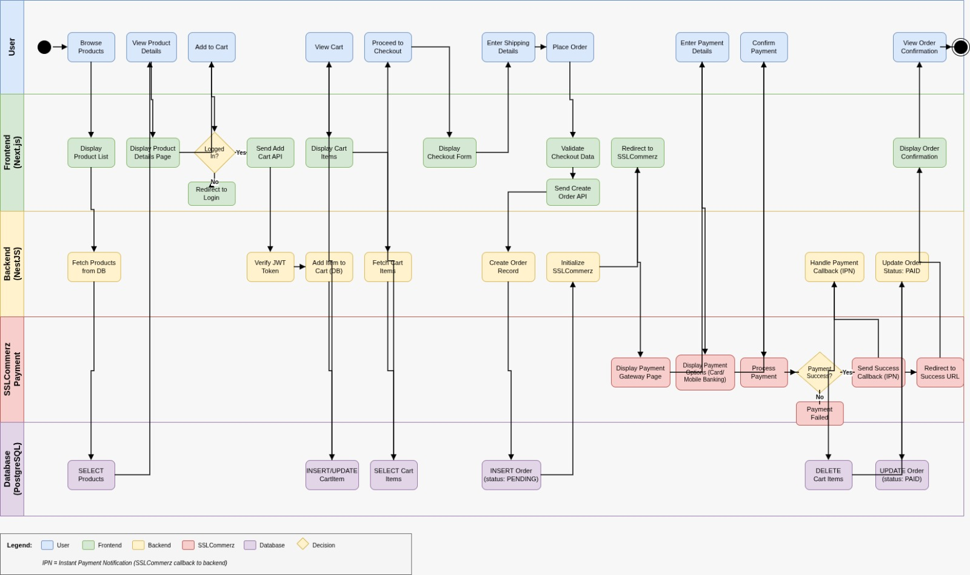

Figure 4.7: Swim-lane Diagram for Product Purchase

#### 4.4 Sequence Diagrams

Sequence diagrams capture the detailed interaction between objects over time for specific use cases.

##### 4.4.1 Sequence Diagram for Registration

Figure 4.8: Sequence Diagram for Registration 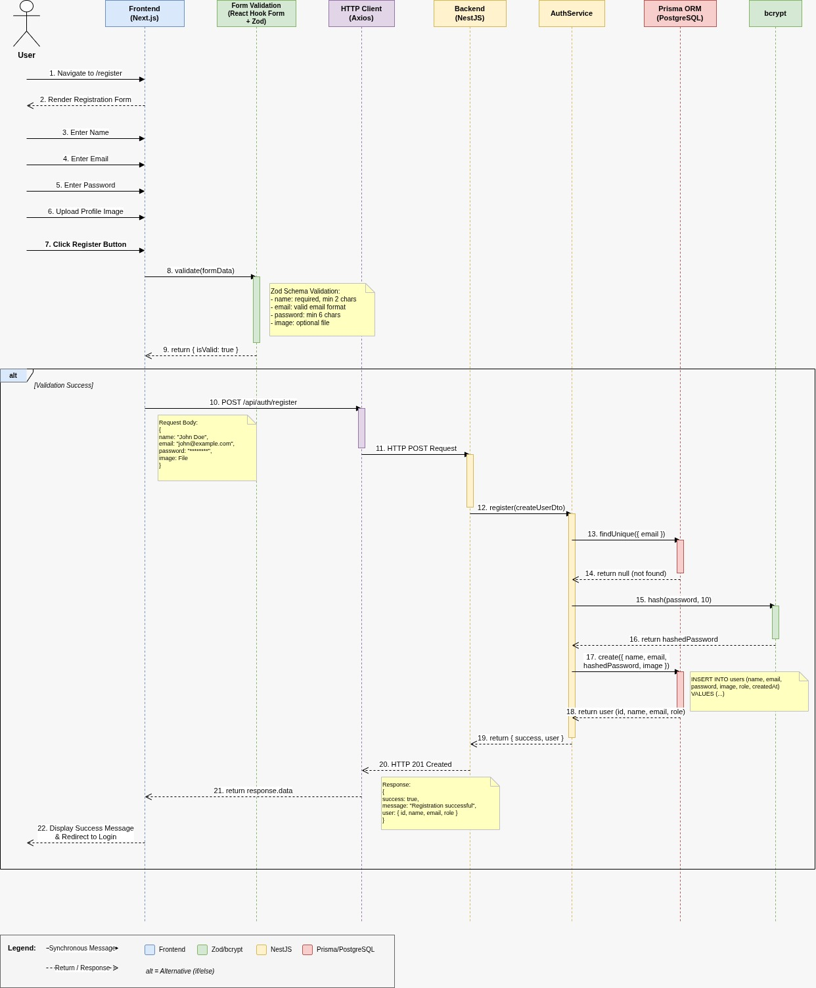

##### 4.4.2 Sequence Diagram for Admin Dashboard

Figure 4.9: Sequence Diagram for Admin Dashboard

##### 4.4.3 Sequence Diagram for Product Purchase

Figure 4.10: Sequence Diagram for Product Purchase

#### 4.5 Class Diagram of the Auraluxe System

The Class Diagram represents the static structure of the system, showing classes, attributes, operations, and relationships.

* User Class: Id, Name, Email, Password, Role (User/Admin/Vendor), Status, CreatedAt, UpdatedAt.
* Product Class: Id, Name, ProductCode, Price, Quantity, KeyFeatures, Specifications, ProductDes, ShippingDelivery, ProductImage, Status.
* Brand Class: Id, Name, Logo, BrandTypeId, Status.
* Category Class: Id, Name, Status.
* Project Class: Id, ProjectName, ProjectImg, Location, Client, Architects, Website, Description, ProjectTypeId, MaterialId.
* Cart Class: Id, UserId, IsDeleted.
* CartItem Class: Id, CartId, ProductId, Quantity, UnitPrice.

**Relationships:**

* User has one Cart (1-to-1).
* Brand has many Products (1-to-Many).
* Category has many Products (1-to-Many).
* Cart has many CartItems (1-to-Many).
* Project belongs to one ProjectType and one Material (Many-to-1).
* Brand belongs to one BrandType (Many-to-1).

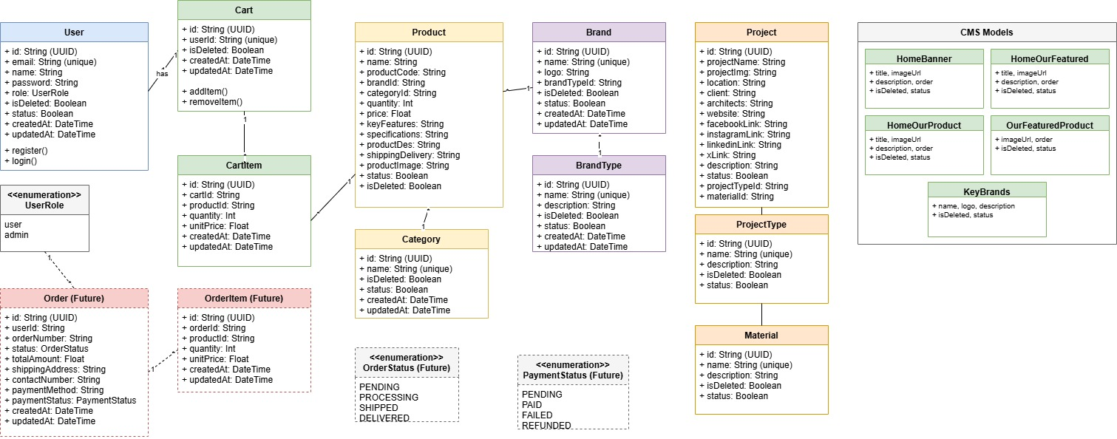

Figure 4.11: Class Diagram of Auraluxe

## **Chapter 5.**

## **Project Management**

#### 5.1 Risk Identification

Risk identification is the first step in the risk management process, involving the discovery and documentation of potential threats that could negatively impact the development or deployment of the Auraluxe system. Given the nature of a premium e-commerce platform dealing with high-value luxury materials, the risks were categorized into technical, operational, and external factors.

Table 5.1: Risk Identification Table

|  |  |  |  |  |
| --- | --- | --- | --- | --- |
| **Risk ID** | **Risk Description** | **Category** | **Probability** | **Impact** |
| **R1** | The risk of SSLCommerz API downtime or integration errors, preventing users from completing high-value transactions. | Technical | Low | High |
| **R2** | The risk of concurrency issues where two users try to buy the last unit of a luxury item simultaneously, leading to negative inventory. | Technical | Medium | High |
| **R3** | High-resolution project/product images causing slow page loads in Next.js, leading to poor user experience (UX) and higher bounce rates. | Technical | High | Medium |
| **R4** | Since Auraluxe is a single-vendor system, unauthorized access to the Admin Dashboard could lead to catastrophic data manipulation (e.g., changing prices of luxury items). | Technical | Low | Critical |
| **R5** | Potential connection timeouts between the NestJS backend and the PostgreSQL database during peak traffic. | Technical | Low | Medium |

#### 5.2 Risk Analysis

Following identification, each risk was analyzed to determine its probability and impact. This allowed us to calculate the Risk Exposure and assign a Priority level to focus mitigation efforts effectively.

Table 5.2: Risk Analysis Table

|  |  |  |  |  |
| --- | --- | --- | --- | --- |
| Risk ID | **Probability (P)** | **Impact (I)** | **Risk Exposure (P × I)** | **Priority** |
| R1 | Low | High | Medium | 2 |
| R2 | Medium | High | High | 1 |
| R3 | High | Medium | High | 1 |
| R4 | Low | Critical | Medium-High | 2 |
| R5 | Low | Medium | Low | 3 |

#### 5.3 Risk Planning

For each identified risk, a specific response strategy was developed. This planning phase ensured that the team was prepared to act immediately should any risk materialize.

Table 5.3: Risk Planning Table

|  |  |
| --- | --- |
| **Risk ID** | **Planned Response / Mitigation Strategy** |
| **R1** | Implement robust error handling in the NestJS backend to catch SSLCommerz failures and return user-friendly error messages instead of crashing the application. |
| **R2** | Use Prisma Transactions (Interactive Transactions) to lock database rows during checkout, ensuring stock is only deducted if the payment is confirmed. |
| **R3** | Utilize Next.js Image Optimization (<Image /> component) to automatically serve resized and WebP-formatted images. Implement lazy loading for the "Project Showcase" section. |
| **R4** | Enforce strict Role-Based Access Control (RBAC) using JWT Guards. Store admin passwords using strong hashing (bcrypt) and implement session timeouts. |
| **R5** | Configure a connection pool in PostgreSQL to manage multiple concurrent connections efficiently. |

#### 5.4 The RMMM Plan

The Risk Mitigation, Monitoring, and Management (RMMM) plan provided a framework for ongoing risk oversight throughout the practicum lifecycle.

1. **Risk Mitigation**

* **Incremental Development:** Adopted an agile approach, delivering the "Product Catalog" and "Admin Dashboard" modules first before attempting complex integrations like SSLCommerz.
* **Type Safety:** Used TypeScript across both frontend and backend to catch type-related errors (e.g., pricing calculations) at compile time rather than runtime.
* **Validation:** Implemented Zod schemas to validate all incoming data, preventing malformed requests from corrupting the database.

1. **Risk Monitoring**

* **API Logging:** Used NestJS interceptors to log the response time and status of every API call.
* **Database Monitoring:** Monitored Prisma query logs during development to identify slow queries (N+1 problems) and optimize them using include or select.
* **Visual Testing:** Regularly tested the UI on mobile devices to ensure the "Project Showcase" was responsive and images loaded correctly.

1. **Risk Management**

* **Fallback Provision:** Created static "Placeholder" images for products in case the dynamic image URL failed to load.
* **Transaction Rollback:** Configured the checkout logic to automatically rollback the entire database transaction if any step (e.g., Payment or Stock Update) failed, preserving data integrity.

Table 5.4: Risk Mitigation, Monitoring, and Management Table

|  |  |  |  |
| --- | --- | --- | --- |
| Risk ID | **Category** | **Mitigation Strategy** | **Monitoring Method** |
| **R1** | Technical (Payment) | Use SSLCommerz Sandbox for all dev testing; Validate IPN callbacks rigorously. | Check server logs for "Payment Failed" events. |
| **R2** | Data Integrity | Use Prisma $transaction API for atomic updates. | Monitor "Order Created" vs "Stock Deducted" counts. |
| **R3** | Performance | Use Next.js SSR for initial load; Cache data with TanStack Query. | Run Lighthouse performance audits on Home and Product pages. |
| **R4** | Security | Protect Admin routes with UseGuards(JwtAuthGuard, RolesGuard). | Log all failed Admin login attempts. |

## **Chapter 6.**

## **Project Planning**

#### Chapter 6: Project Planning

To ensure successful execution, the Auraluxe project required a structured project plan. This involved defining project objectives, system scope, and critical milestones such as requirements analysis, database schema design (Prisma), API development (NestJS), frontend implementation (Next.js), and testing. The plan also addresses resource allocation and risk management strategies. Key deliverables include administrative features (inventory management, project portfolio showcasing, order fulfillment), and user features (product filtering, cart management, secure SSLCommerz payments, and project inspiration viewing). The system ensures a premium user experience with server-side rendering for performance and secure role-based access control.

The following activities of project planning were followed in this system:

1. Estimation of project effort and resources.
2. Task prioritization based on dependencies (e.g., Backend APIs before Frontend UI).
3. Personnel requirements for development and testing.
4. Estimation of project cost and schedule.
5. Version control (Git/GitHub) for proper code and document management.

#### 6.1 System Project Estimation

The accuracy of estimation in the Auraluxe System depends on:

* **Estimating product size:** Scope includes modules such as User/Admin Authentication, Product Catalog Management (with Brands/Categories), Project/Inspiration Showcase, Cart & Order Lifecycle, Payment Gateway Integration, and the Admin Dashboard.
* **Effort, Calendar Time, and Cost:** Time and cost are estimated considering system complexity (specifically relational data integrity between Projects/Materials and the Order transaction flow), number of modules, and skill requirements. This involves effort for strict type-checking (TypeScript), Zod validation setup, and responsive UI implementation.
* **Consistency of requirements:** Requirements are kept stable throughout development, focused on the core "Single Vendor E-commerce" value proposition.

#### 6.2 Function-Oriented Metrics

The project estimation is based on function point analysis, which considers both data functions and transactional functions.

1. **Data Functions**

* **Internal Logical Files (ILF):** Data maintained within the system via PostgreSQL, such as Users, Products, Projects, Brands, Carts, Orders, and Home Banners.
* **External Interface Files (EIF):** Interfaces connecting to external services like SSLCommerz (Payment Gateway) and potentially external Image Hosting/CDN services.

1. **Transactional Functions**

* **External Inputs (EI):** User actions such as registering, adding items to cart, placing an order, and Admin actions like creating products, uploading project details, or updating banner images.
* **External Outputs (EO):** Order Invoices, Payment Success/Fail Messages, Admin Sales Reports.
* **External Inquiries (EQ):** Real-time queries such as filtering products by Brand/Category, searching for products, and viewing Project details.

#### 6.3 Identifying Complexity

##### 6.3.1 Identifying Complexity of Transaction Functions

* **Low complexity:** Simple inputs such as user login, logout, subscribing to newsletters, or viewing static "About Us" pages.
* **Medium complexity:** Product creation (requires linking Brand/Category + Image upload), updating Cart quantities, and filtering products by multiple attributes.
* **High complexity:** The Checkout process (involves stock validation -> order creation -> payment redirect), Secure Payment Handling (SSLCommerz IPN callbacks), and Dynamic Project Showcasing (linking Materials to Projects).

##### 6.3.2 Identifying Complexity of Data Functions

* **Low complexity:** Simple lookup tables such as BrandType, Category, Material, or ProjectType.
* **Medium complexity:** User profiles (Info + Role + Status) and HomeBanner configurations.
* **High complexity:** Product (links to Brand, Category, CartItems, OrderItems), Project (links to ProjectType, Material, Images), and Order (links to User, Payments, Status History).

##### 6.3.3 Unadjusted Function Point Contribution

Table 6.1: Unadjusted Function Point Contribution (Transaction Function)

|  |  |  |  |  |
| --- | --- | --- | --- | --- |
| **Transaction Functions** | **FTRs** | **DETs** | **Complexity** | **UFP** |
| User/Provider Registration (EI) | 2 | 15 | Average | 4 |
| Authentication (Login/Reset) (EI) | 1 | 5 | Low | 3 |
| Search Products (Filter/Sort) (EQ | 2 | 12 | High | 6 |
| View Project Details (EQ) | 2 | 15 | Average | 4 |
| Admin: Create/Edit Product (EI) | 4 | 20 | High | 6 |
| Admin: Create/Edit Project (EI) | 3 | 15 | High | 6 |
| Add to Cart / Update Cart (EI) | 2 | 8 | Average | 4 |
| Checkout & Payment Init (EI) | 3 | 15 | High | 6 |
| Payment Verification (SSL) (EI) | 2 | 10 | High | 6 |
| Admin: Update Order Status (EI) | 2 | 5 | Average | 4 |
| Admin: Dashboard Stats (EO) | 2 | 10 | Average | 5 |
| **Total (Transaction)** |  |  |  | **54** |

##### 6.3.4 Unadjusted Function Point Contribution

Table 6.2: Unadjusted Function Point Contribution (Data Function)

|  |  |  |  |  |
| --- | --- | --- | --- | --- |
| **Data Function (ILF/EIF)** | **FTRs** | **DETs** | **Complexity** | **UFP** |
| Model: User (ILF) | 2 | 10 | Average | 10 |
| Model: Product (ILF) | 4 | 20 | High | 15 |
| Model: Project (ILF) | 3 | 15 | High | 15 |
| Model: Order/Cart (ILF) | 3 | 12 | High | 15 |
| Model: Brand/Category (ILF) | 1 | 5 | Low | 7 |
| Model: HomeBanner (ILF) | 1 | 6 | Low | 7 |
| SSLCommerz API (EIF) | 1 | 15 | Average | 7 |
| **Total (Data)** |  |  |  | 76 |

##### 6.3.5 Performance and Environmental Impact

Table 6.3: Performance and Environmental Impact (GSC)

|  |  |
| --- | --- |
| **General System Characteristic** | **Rating** |
| Data Communications (API Calls) | 4 |
| Distributed Data Processing | 2 |
| Performance (SSR/SEO requirements) | 5 |
| Heavily Used Configuration | 2 |
| Transaction Rate | 4 |
| Online Data Entry | 4 |
| End-user Efficiency | 4 |
| Online Update | 3 |
| Complex Processing (Geospatial) | 3 |
| Reusability | 4 |
| Installation Ease | 3 |
| Operational Ease | 3 |
| Multiple Site | 1 |
| Facilitate Change | 4 |
| Total Degree of Influence (TDI) | 46 |

##### 6.3.6 Counting Adjusted Function Point

**Function Point Calculation**

* UFP for Transaction = 54
* UFP for Data = 76
* Total UFP = 130
* Value Adjustment Factor (VAF) = 0.65 + (0.01 × 46) = 1.11
* **Adjusted FP (AFP) = 130 × 1.11 = 144.3 (approx 144)**

**Effort & Schedule Calculation**

* Effort = AFP ÷ Productivity
  + Note: Standard productivity for a full-stack developer using modern tools (MERN) is approx 15-20 FP/month.
  + Effort = 144 ÷ 18 ≈ 8.0 person-months

**Schedule (Duration):**

* Since I am working as a single developer for this practicum, but focusing on a specific subset of features (MVP) for the report:
* Target Duration = 3 to 4 months (Standard Semester Duration).
* This confirms the project scope is appropriate for a comprehensive semester-long internship project.

#### 6.4 Project Scheduling (Gantt Chart)

Project scheduling involves sequencing activities and assigning timeframes to ensure the timely completion of the Auraluxe platform. The schedule was designed to fit within a 14-week internship period, dividing the workload into distinct phases: Analysis, Design, Development, Integration, and Testing.

The timeline uses a Gantt Chart approach to visualize the critical path. The backend (NestJS) and database (Prisma) were prioritized to ensure the API was ready before the frontend (Next.js) integration began.

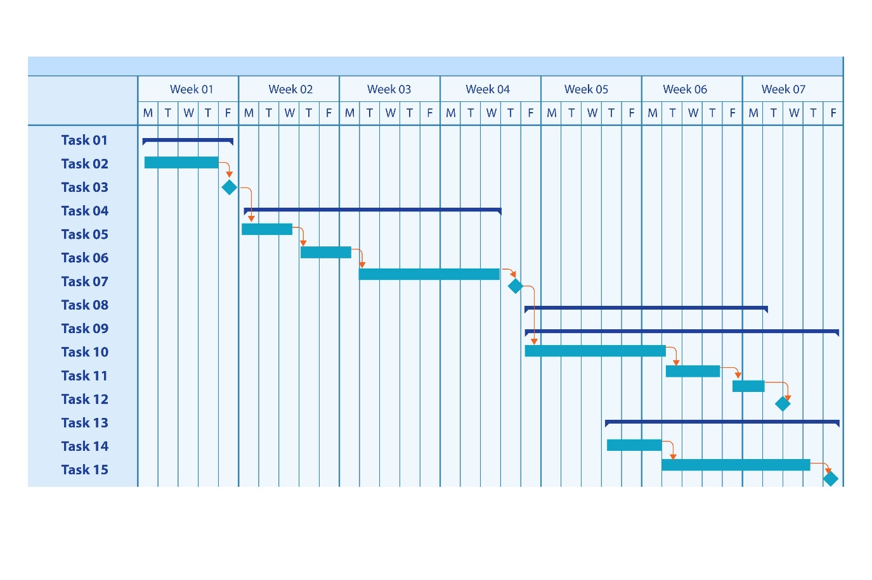Figure 6.1: Project Schedule Gantt Chart

Development is carried out in three incremental 2-week phases: Phase 1 implements core Authentication and Role-Based Access Control to secure Admin and User portals, Phase 2 delivers the dynamic Product Catalog and the unique Project Inspiration Showcase, and Phase 3 completes the Shopping Cart logic and secure SSLCommerz Payment Integration. The schedule concludes with a 1-week Testing phase for validation and bug fixes, and a final 1-week Deployment phase for documentation and presentation, ensuring all dependencies are addressed.

#### 6.5 Accounts Table

Project costs are estimated based on a standard development environment for a medium-scale commercial e-commerce application.

##### 6.5.1 Personnel Cost

The largest portion of the budget is dedicated to personnel, as skilled manpower is essential for successful full-stack development and deployment.

Table 6.4: Personnel Cost

|  |  |  |  |  |
| --- | --- | --- | --- | --- |
| **Role** | **No. of Persons** | **Est. Cost (Monthly)** | **Duration** | **Total** |
| Project Manager | 1 | 80,000 BDT | 3 Mos | 240,000 BDT |
| Backend Developer | 1 | 60,000 BDT | 3 Mos | 180,000 BDT |
| Frontend Developer | 1 | 40,000 BDT | 3 Mos | 80,000 BDT |
| Total Personnel |  |  |  | 500,000 BDT |

#### 6.5.2 Expected Hardware Cost

To support development, testing, and hosting, certain hardware resources are required.

Table 6.5: Expected Hardware Cost

|  |  |  |  |
| --- | --- | --- | --- |
| **Item** | **Quantity** | **Unit Price** | **Total Cost** |
| Development Laptops | 3 | (Existing Assets) | 0 BDT |
| Local Server (Testing) | 1 | 5,000 BDT | 5,000 BDT |
| **Total Hardware** |  |  | **5,000 BDT** |

##### 6.5.3 Expected Software Cost

Licensed software and development tools are also considered in the cost structure.

Table 6.6: Expected Software Cost

|  |  |  |
| --- | --- | --- |
| **Item** | **Type** | **Cost** |
| Visual Studio Code | IDE | Free (Community) |
| PostgreSQL (Local/Neon) | Database | Free Tier |
| Vercel Pro (Deployment) | Hosting | 2,200 BDT (Monthly) |
| SSLCommerz Sandbox | Payment Gateway | Free |
| Domain Name (.com) | Web | 1,200 BDT |
| **Total Software** |  | **34,00 BDT** |

#### 6.5.4 Expected Other Cost

Other costs include miscellaneous but essential expenses.

Table 6.7: Expected Other Cost

|  |  |  |
| --- | --- | --- |
| **Item** | **Description** | **Cost** |
| Internet & Utility | High-speed connection | 6,000 BDT |
| Documentation | Printing & Binding | 2,000 BDT |
| Miscellaneous | Contingency fund | 5,000 BDT |
| **Total Other** |  | **13,000 BDT** |

**Grand Total Estimated Project Cost:** 5021,400 BDT

#### 6.6 Clarification of Academic vs. Industry Estimates

It is important to note that this budget represents an industry implementation scenario for a company like "Tilottoma." In the context of this practicum report, the actual cost was close to zero because the project was completed as an academic exercise using free open-source tools (NestJS, Next.js, Postgres) and personal resources. The detailed accounts table therefore illustrates what an organization might expect to spend if deploying the Auraluxe system commercially, while the student project itself required minimal financial investment.

## **Chapter 7.**

## **Designing**

This chapter presents the overall design aspects of the **Auraluxe** software system. The design phase translates the system requirements identified during the analysis stage into a structured and detailed blueprint that guides the implementation of the Next.js frontend and NestJS backend. Emphasis is placed on user interface aesthetics, data flow modeling, and relational database architecture to ensure the usability, maintainability, and scalability required for a premium e-commerce platform.

#### 7.1 Interface Design

Interface design focuses on ensuring effective and visually appealing interaction between users and the system. Given that Auraluxe deals with luxury building materials and architectural inspiration, the user interface (UI) has been designed with a focus on minimalism, high-quality imagery, and elegance.

The proposed system applies standard design principles such as:

* **Visual Hierarchy:** Prioritizing product images and project portfolios to drive user engagement.
* **Responsive Layout:** Ensuring a seamless shopping experience across desktops, tablets, and mobile devices using the **Next.js** framework.
* **Consistent Navigation:** Providing clear pathways between the "Product Catalog," "Project Inspiration," and "Cart" modules.

Input validation messages (powered by **Zod**) and system feedback mechanisms (such as toast notifications for "Added to Cart") are incorporated to reduce user errors and provide immediate confirmation, ensuring a smooth and confident user journey.

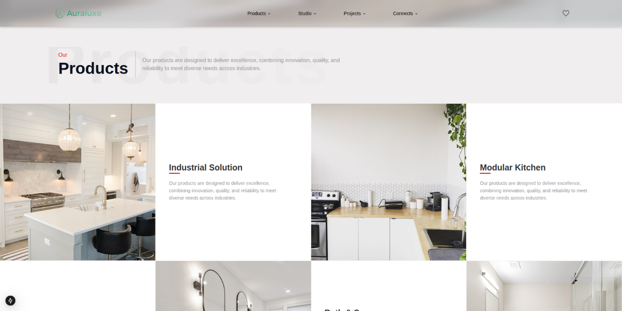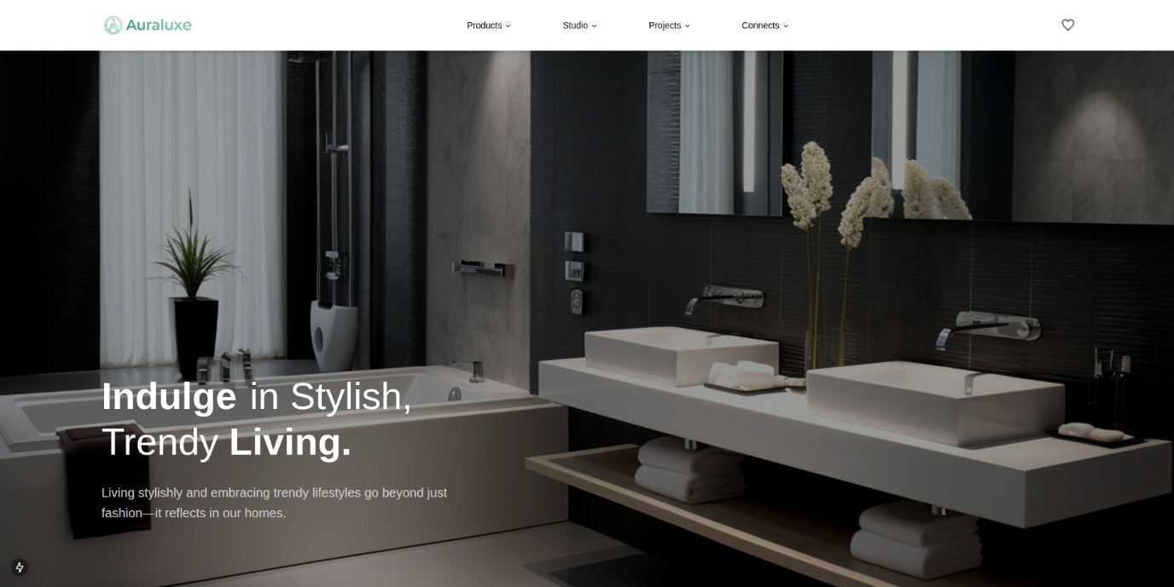Figure 7.1: Hero Section of Home Page

Figure 7.2: Our Product Section of Home Page

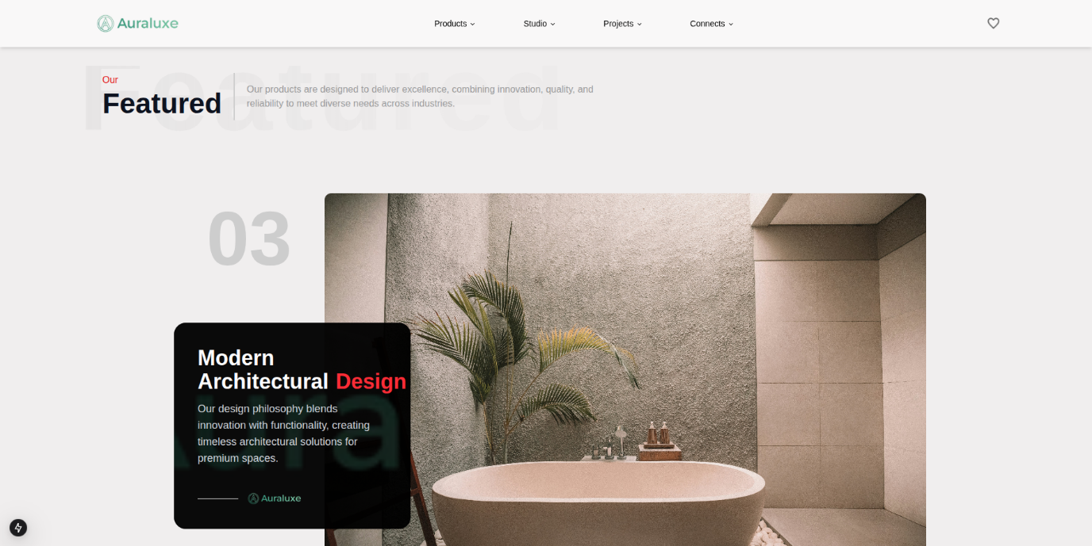Figure 7.3: Our Featured Section of Home Page

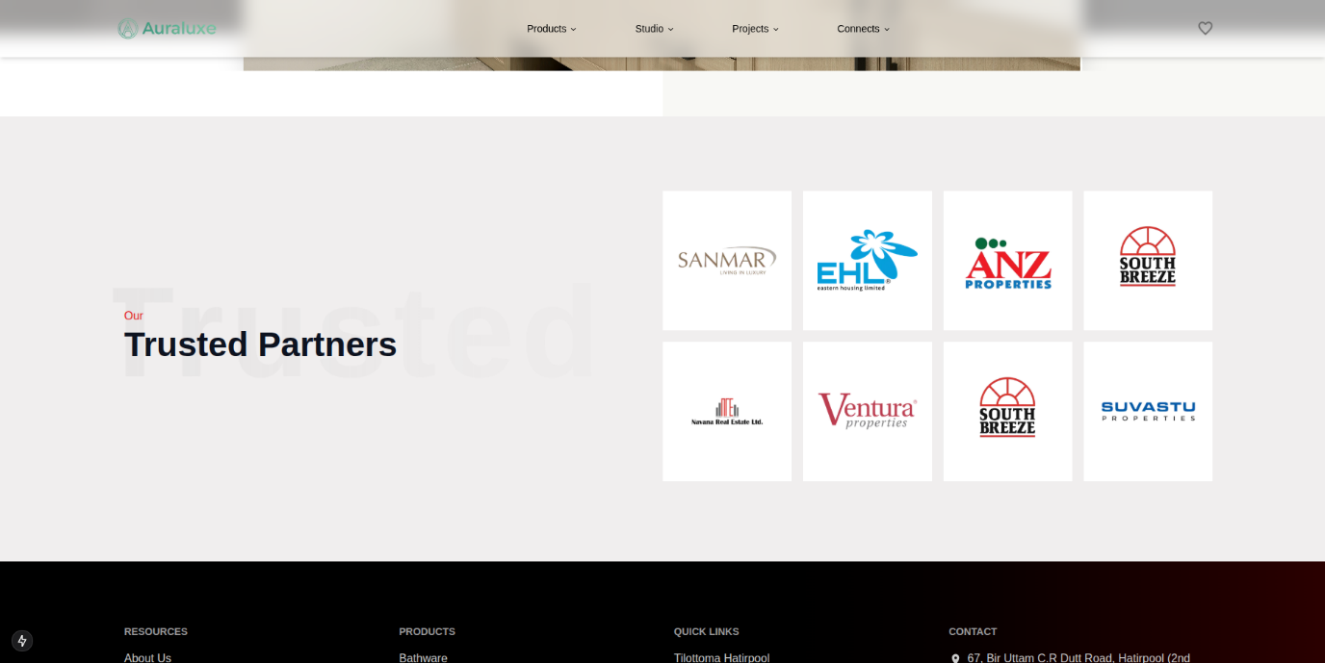

Figure 7.4: Trusted Partner Section

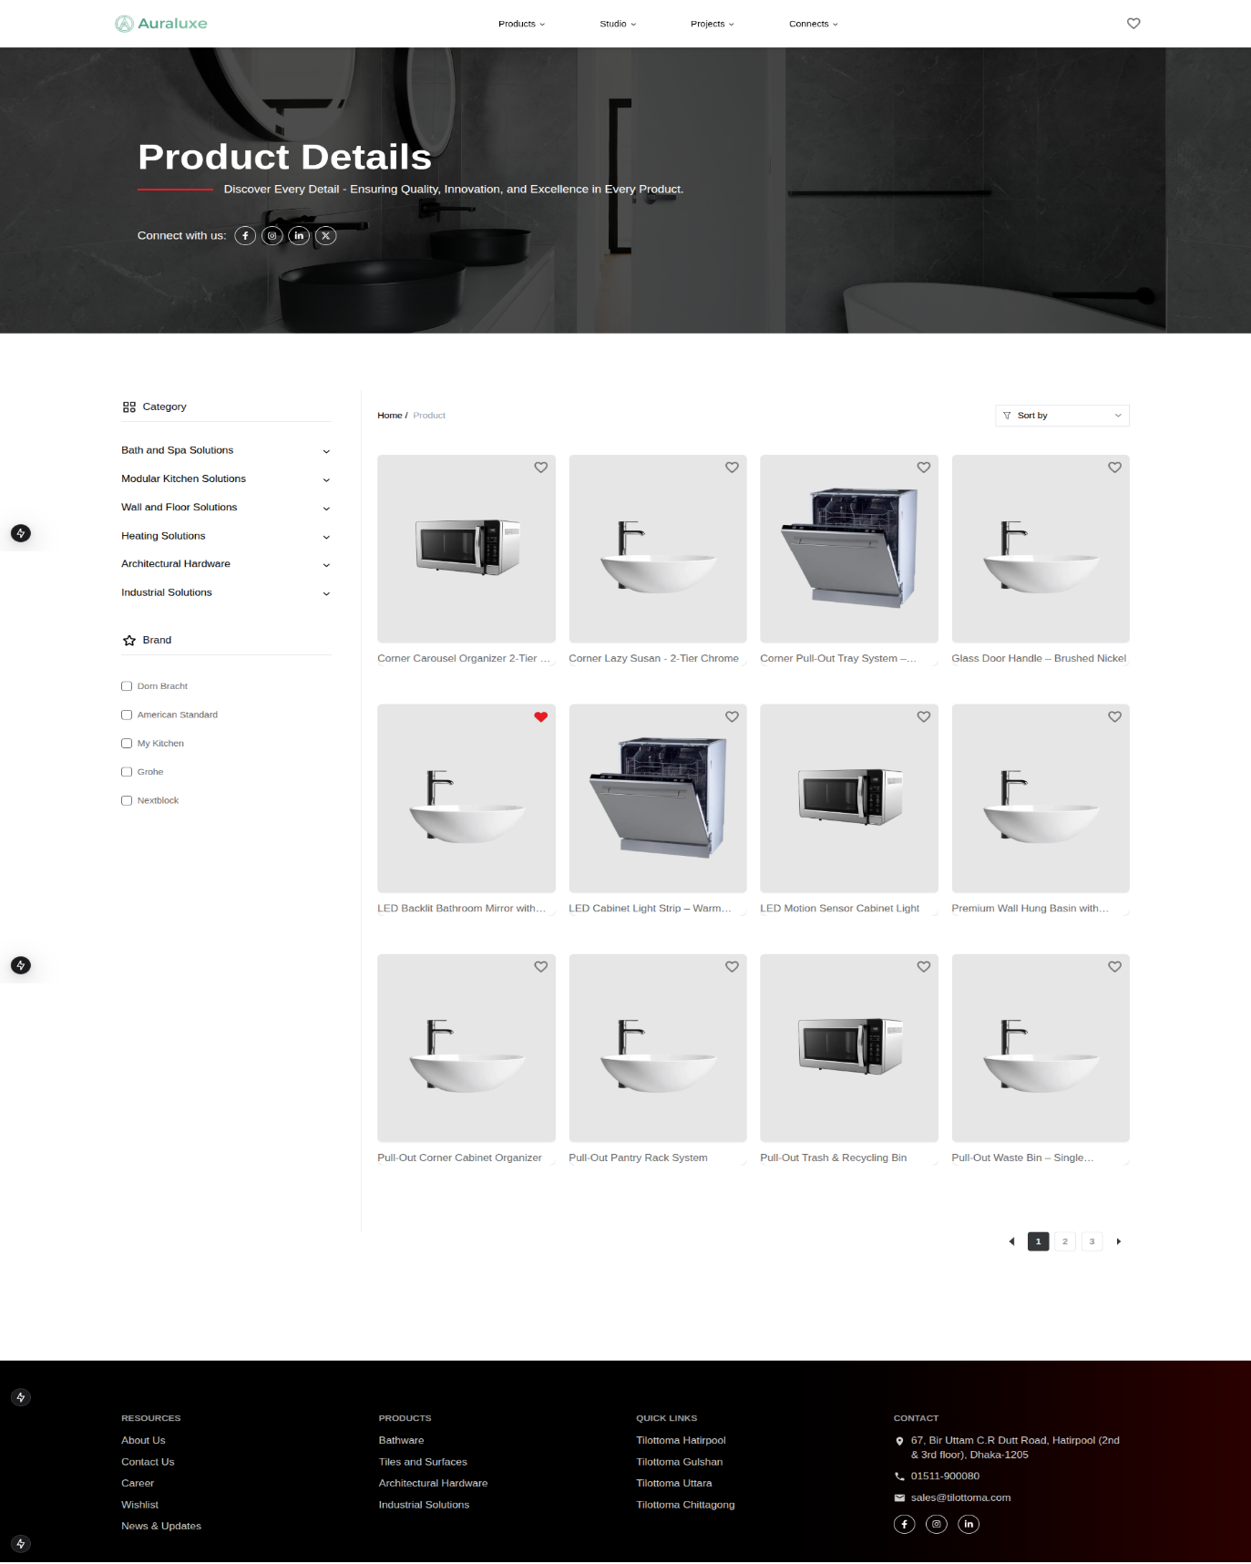

Figure 7.5: Product Page

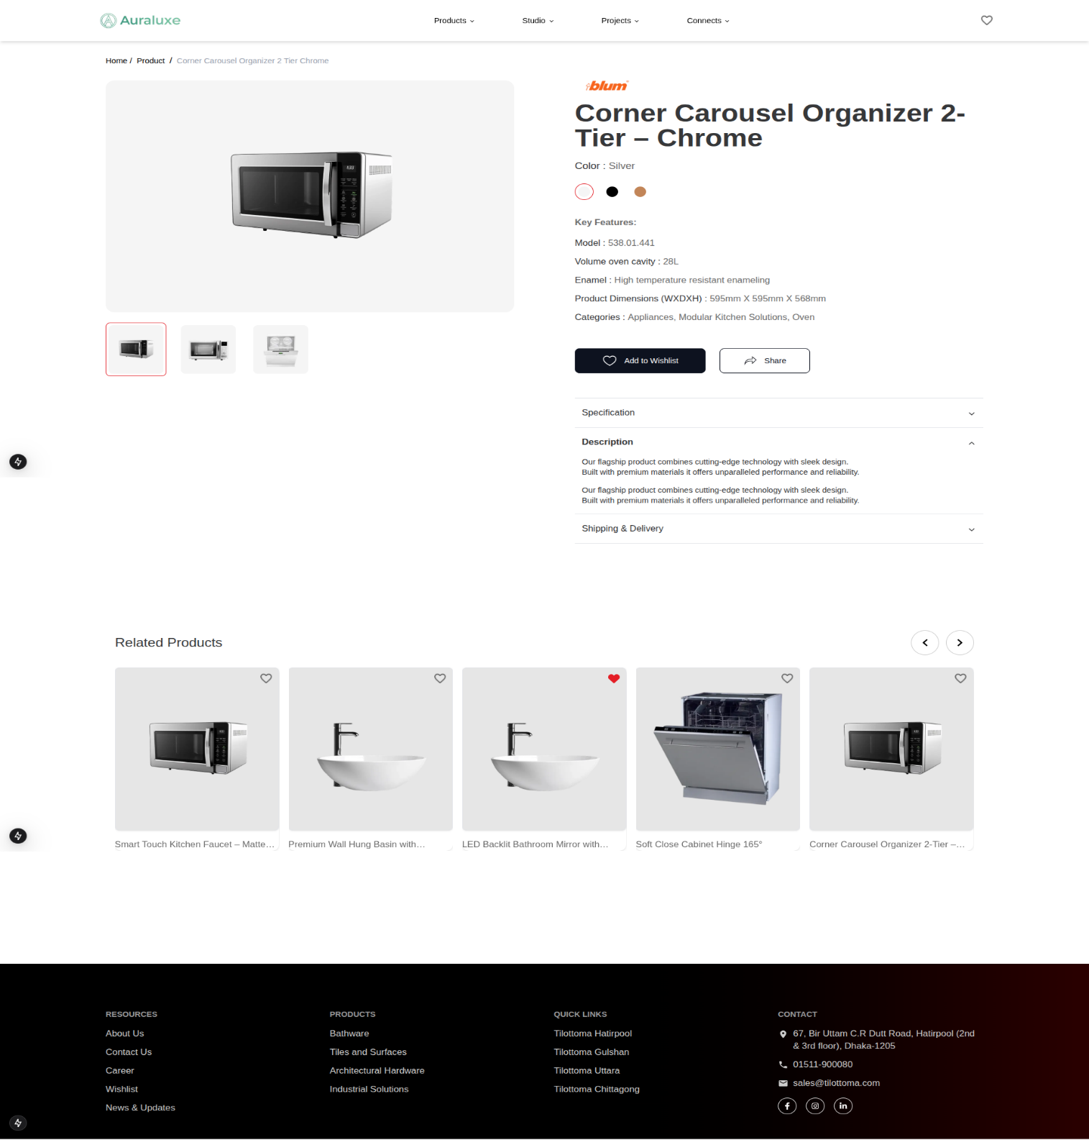Figure 7.6: Product Detail Page

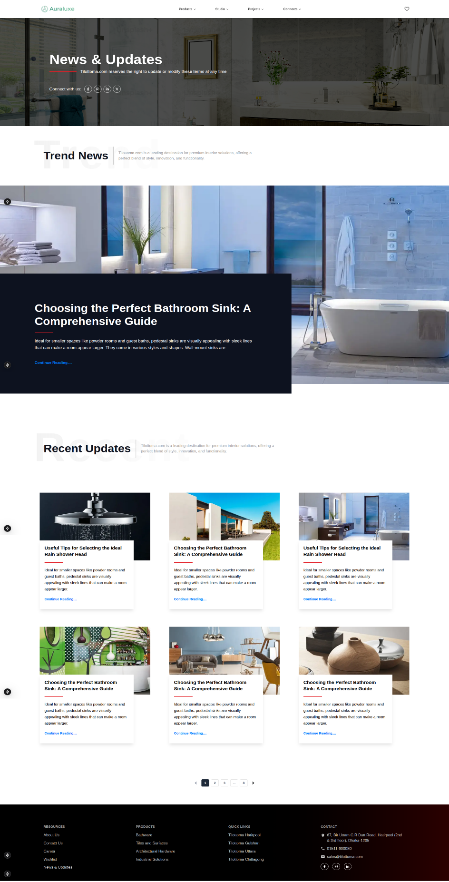

Figure 7.7: News and Update Page

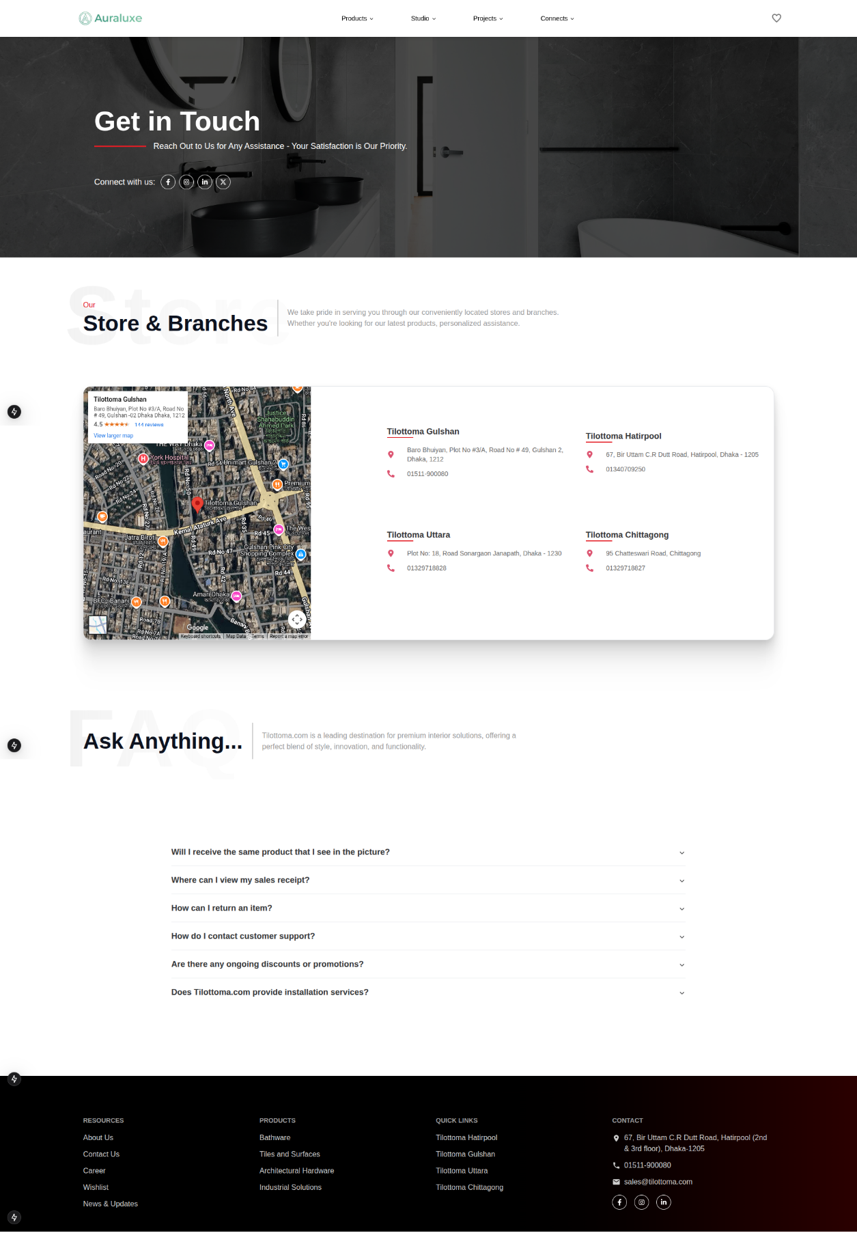Figure 7.8: Contact Us Page

Figure 7.9: Project Page 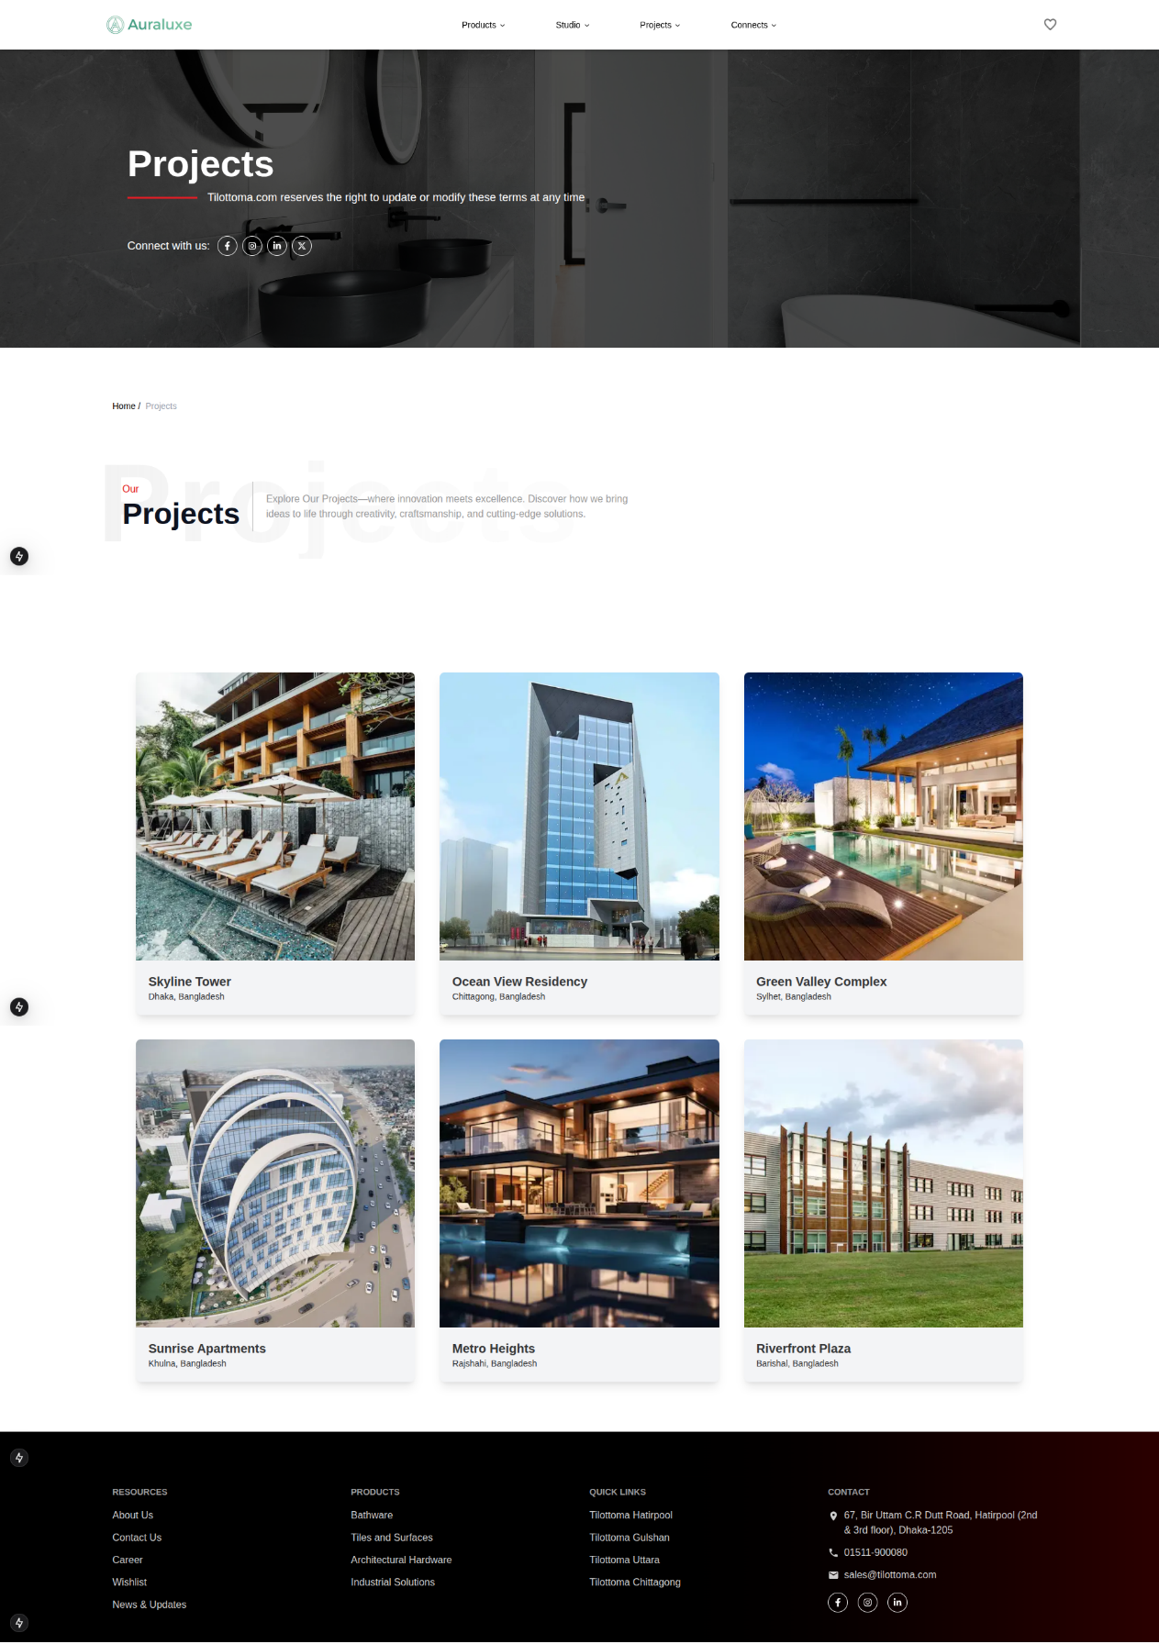

Figure 7.10: Project Detail Page 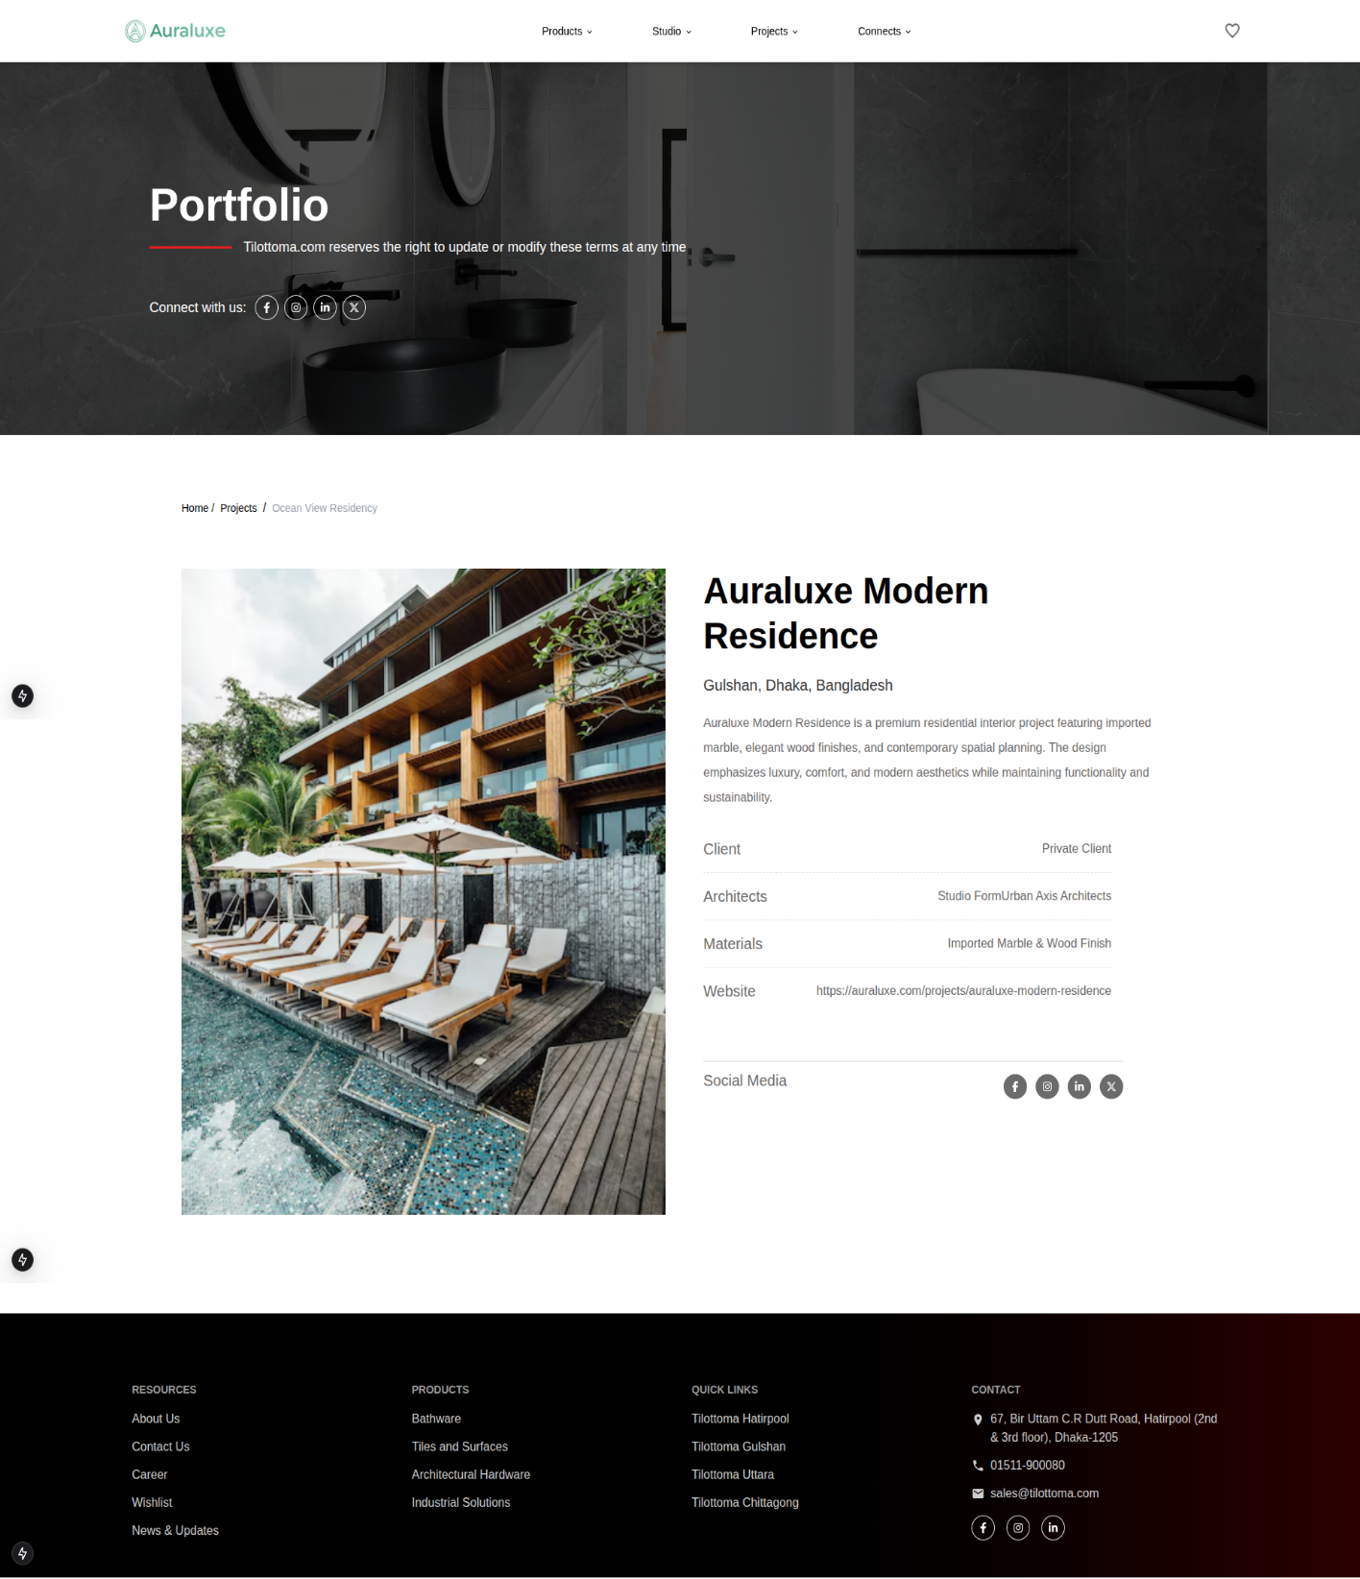

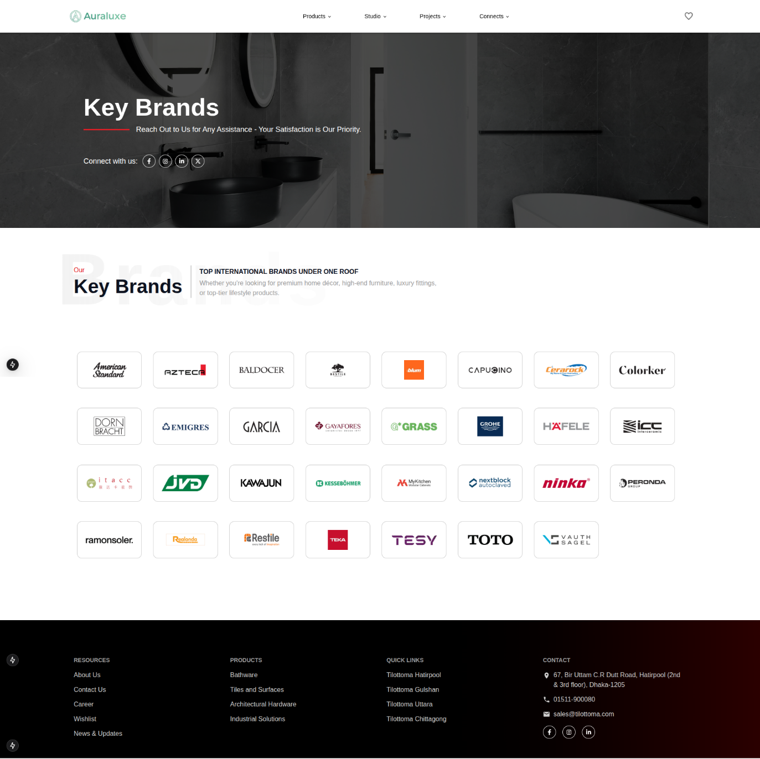

Figure 7.11: Key Brands Page

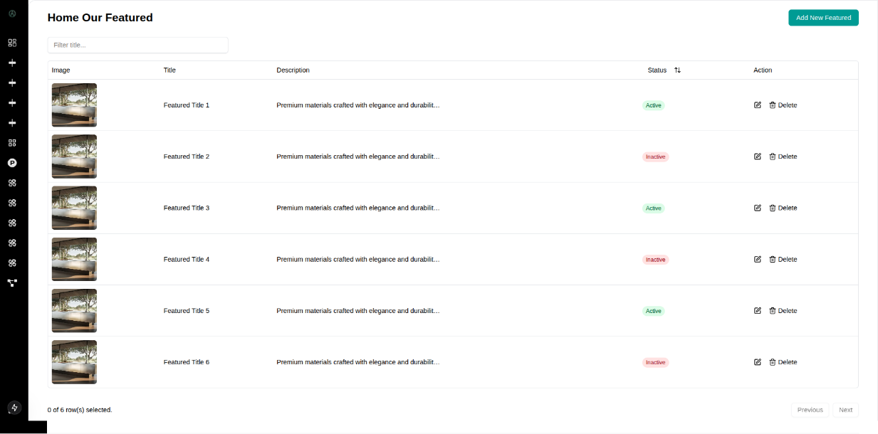Figure 7.12: Admin Dashboard Home Featured Product page

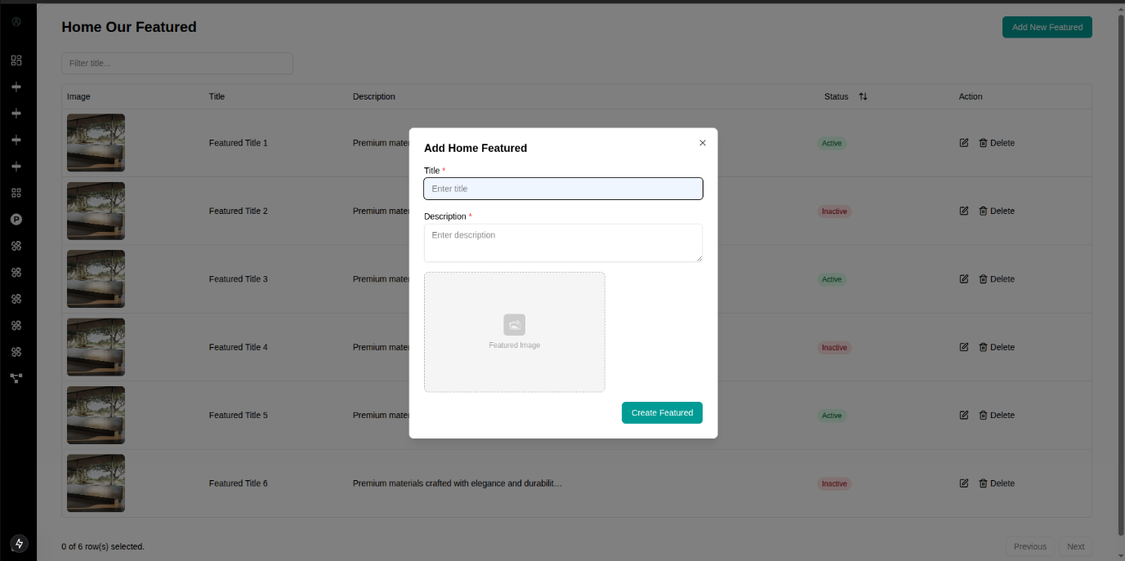

Figure 7.13: Admin Dashboard Home Featured Add Form

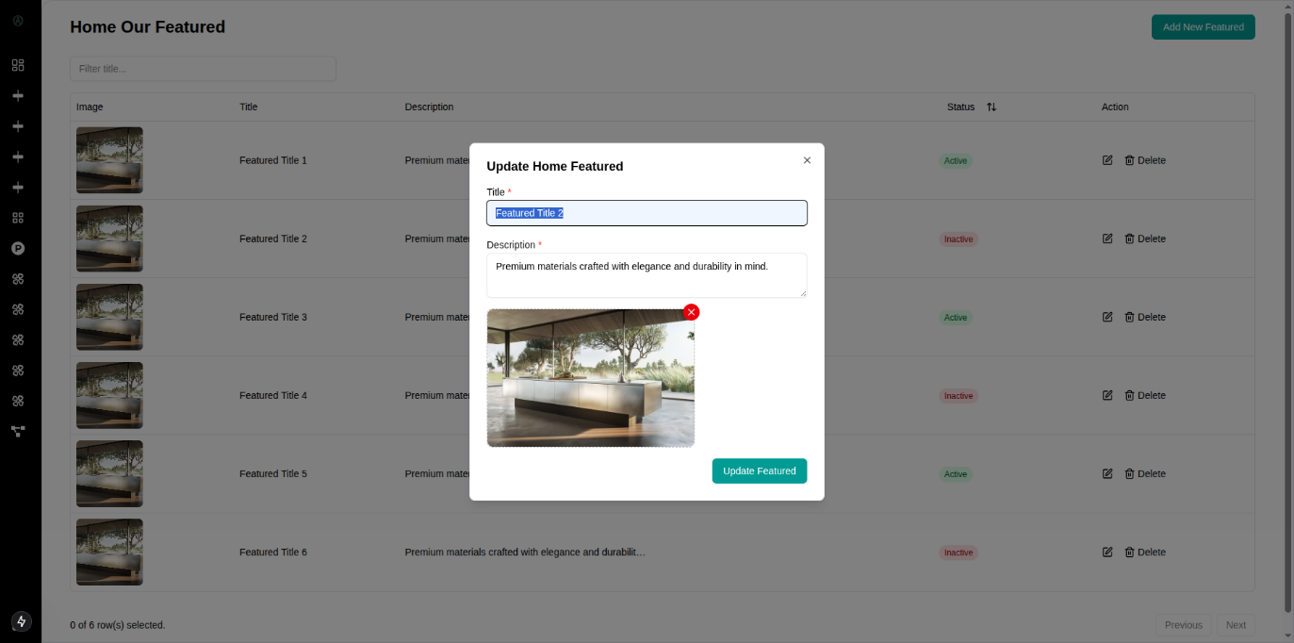

Figure 7.14: Admin Dashboard Home Featured Update Form

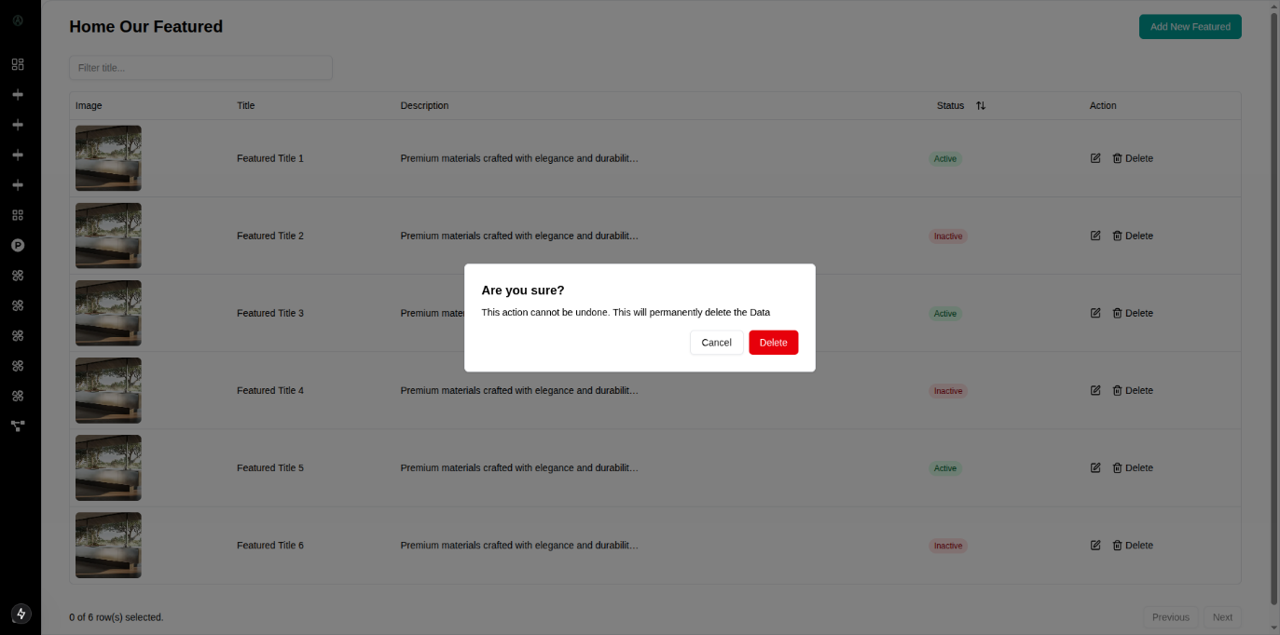

Figure 7.15: Admin Dashboard Product Delete Warning

#### 7.2 Data Flow Diagram (DFD)

A Data Flow Diagram (DFD) maps out the flow of information for any process or system. It uses defined symbols like rectangles, circles, and arrows to show data inputs, outputs, storage points, and the routes between each destination. For Auraluxe, the DFD visualizes how customer requests are processed into orders and how the admin manages the inventory and project portfolios.

##### 7.2.1 Context-Level DFD (Level 0)

The Level 0 DFD represents the entire Auraluxe system as a single process interacting with external entities.

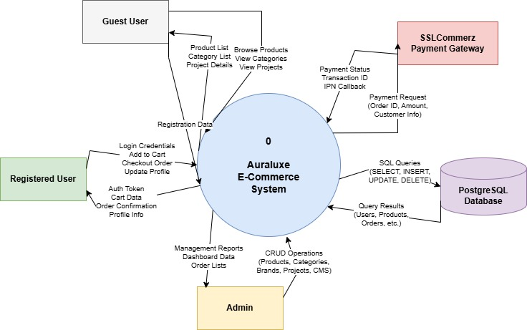

Figure 7.27: Context Level DFD (Level 0)

**External Entities:**

* **User (Customer):** Browses products, views project inspiration, and places orders.
* **Administrator:** Manages products, projects, and order fulfillment.
* **SSLCommerz (Payment Gateway):** Handles secure transaction processing.

**Data Flows:**

* User sends Login Credentials and Search Queries to the System.
* System returns Product Details and Project Portfolios to the User.
* User submits Order Details and Payment Info.
* System forwards payment request to SSLCommerz.
* SSLCommerz returns Payment Status (Success/Fail) to the System.
* Admin inputs New Product Data and Project Images.
* System provides Sales Reports and Order Notifications to the Admin.

##### 7.2.2 DFD Level 1

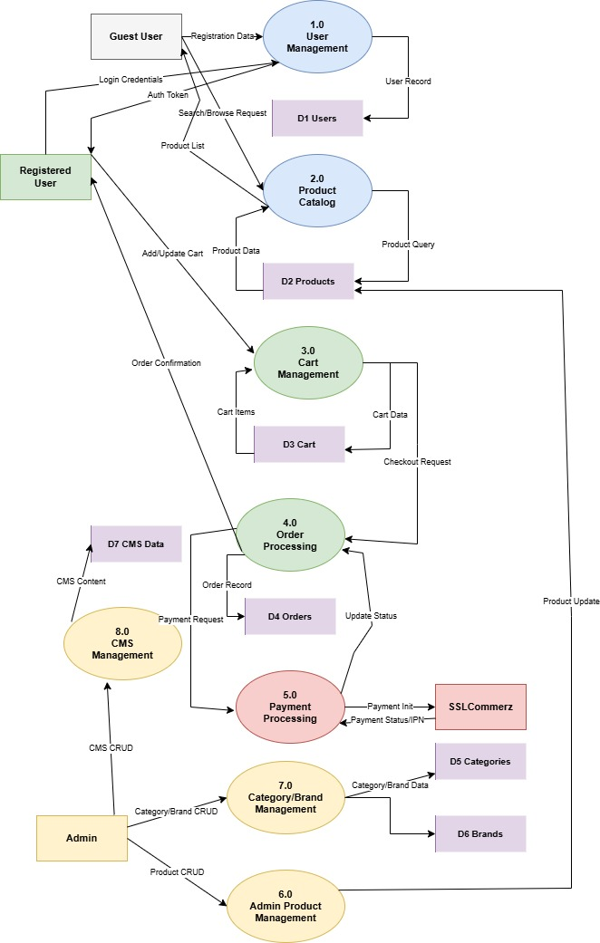The Level 1 DFD decomposes the main system into specific sub-processes, clarifying how data is transformed within the application.

Figure 7.28: Level 1 DFD

**Key Processes:**

* Authentication Process: Handles login/registration for Users and Admins. Verifies credentials against the User Table.
* Product Management: Admin adds/updates items. Users query this process to view the Product Table and Brand Table.
* Project Showcase Engine: Unique to Auraluxe, this process links Projects to Materials. When a user views a project, this process fetches the associated material details.
* Order Processing: Receives items from the Cart, checks stock in the Product Table, and creates a record in the Order Table.
* Payment Handling: Interacts with the external SSLCommerz API and updates the Order Status upon successful transaction.

**Data Stores:**

* D1: User Database (Credentials, Profiles)
* D2: Product Inventory (Stock, Prices, Specs)
* D3: Project Portfolio (Images, Descriptions, Relations)
* D4: Order Records (Transaction History)

##### 7.2.3 DFD Level 2

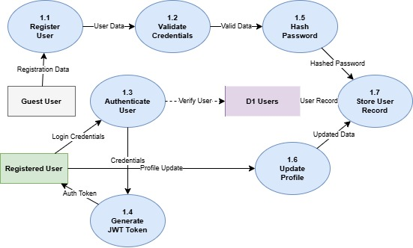**P1.1** User Registration & Verification: Collects user registration data, validates input, creates user account, and triggers email verification.

Figure 7.29: DFD Level 2 Process 1 - User Registration

**P2.1 Browse & Search Products:** Allows users to search products using keywords, filter by category/brand/price, and retrieves relevant product listings from the Product data store.

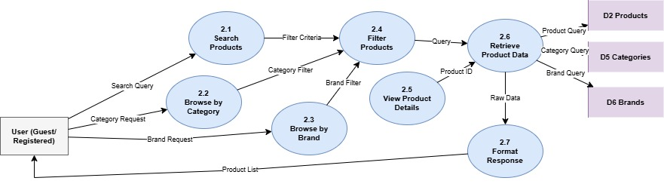

Figure 7.30: DFD Level 2 Process 2 - Product Browsing

**P3.1 Add to Cart:** Collects product selection and quantity, validates product availability, checks if item exists in cart (update quantity or create new entry).

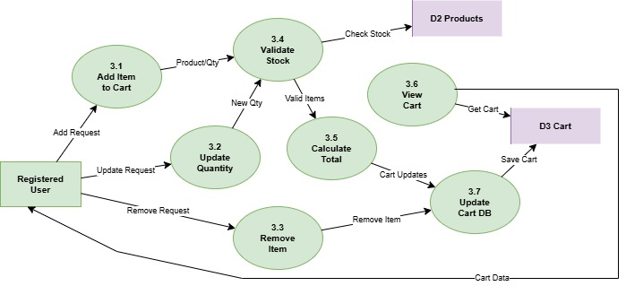

Figure 7.32: DFD Level 2 Process 3.1 - Add to Cart

**P4.1 Order:** Collects checkout information, validates cart items, creates order record with pending payment status, and reserves inventory.

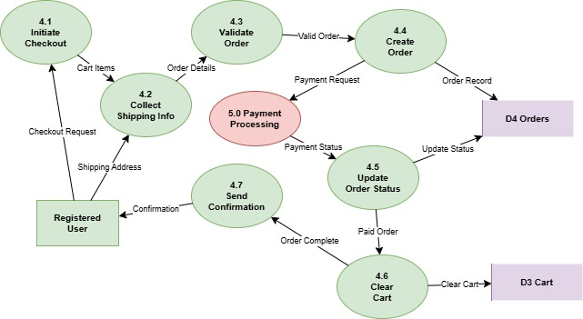Figure 7.34: DFD Level 2 Process 4.1 - Order

**P5.1 Process Payment:** Retrieves order details, initiates SSLCommerz payment session, redirects user to payment gateway, receives payment callback, validates transaction, and updates order status.

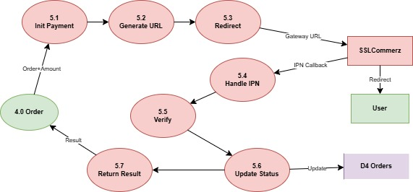

Figure 7.35: DFD Level 2 Process 5 - Payment Processing

**P6.1 Manage Product:** Admin creates/updates/deletes products with details (name, product code, price, quantity, key features, specifications, description, shipping/delivery info), assigns category and brand, uploads product images, and manages inventory status.

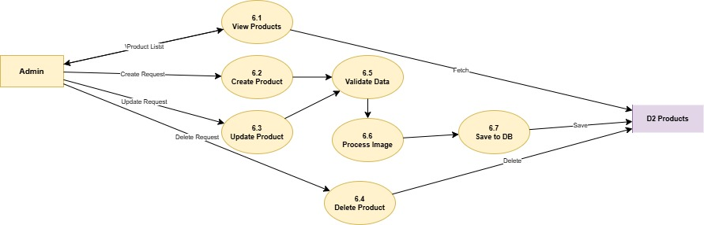

Figure 7.35: DFD Level 2 Process 6 - Product Management

#### 7.3 Database Design

Database design plays a critical role in ensuring that the Auraluxe E-commerce System is efficient, scalable, and reliable. The database is designed to manage users, products, categories, brands, shopping carts, orders, payments, projects, and home page content. A relational database approach using PostgreSQL is adopted to maintain data integrity, minimize redundancy, and support complex relationships between entities such as products, categories, brands, and carts.

The design supports core system functionalities including product catalog management, shopping cart operations, order processing, payment tracking, content management, and project portfolio display.

##### ****7.3.1 Normalization of Data Fields****

To ensure data consistency and eliminate redundancy, the Auraluxe database is normalized up to the Third Normal Form (3NF).

1. **First Normal Form (1NF)**

* All tables contain atomic values.
* No repeating groups or multivalued attributes exist.
* Example: Product features and specifications are stored as separate text fields rather than arrays. Key features, specifications, and descriptions are individual columns.

1. **Second Normal Form (2NF)**

* All non-key attributes fully depend on the primary key.
* Example: In the Product table, attributes such as name, price, quantity, and specifications depend entirely on the product id.
* In the CartItem table, quantity and unit price depend on the composite relationship between cartId and productId.

1. **Third Normal Form (3NF)**

* Non-key attributes are independent of each other.
* Example: Brand information (name, logo, brandTypeId) is stored only in the Brand table and not duplicated in Product table. Products reference brands through brandId foreign key.
* Category details are stored in the category table, and products reference them through categoryId.

This normalization approach improves data integrity, reduces update anomalies, and enhances database maintainability.

##### ****7.3.2 Entity Relationship (ER) Model****

The ER model of the Auraluxe system defines key entities and their relationships as follows:

* **User:** Represents all system users (customers, admins, vendors). Stores personal information, credentials, role, and account status.
* **Product:** Represents building materials and interior products available for purchase. Each product belongs to a category and a brand, includes detailed specifications, features, descriptions, and pricing information.
* **category:** Defines product categories for organizational hierarchy (e.g., Tiles, Fixtures, Lighting, Furniture).
* **Brand:** Represents product brands/manufacturers. Each brand belongs to a brand type.
* **brandType:** Categorizes brands by their specialization or product line focus.
* **Cart:** Represents a user's shopping cart. One user has one cart.
* **CartItem:** Individual items within a shopping cart. Links cart to products with quantity and unit price.
* **Project:** Showcases completed projects using Auraluxe products. Includes project details, location, client information, architects, and social media links.
* **projectType:** Categories for different types of projects (e.g., Residential, Commercial, Hospitality).
* **material:** Types of materials used in projects for classification.
* **homeBanner:** Home page banner/hero section content with images, titles, descriptions, and display order.
* **homeOurFeatured:** "Our Featured" section content for home page.
* **homeOurProduct:** "Our Products" section content for home page.
* **ourFeaturedProduct:** Featured product highlights with images and display order.
* **keyBrands:** Showcase of key/premium brands on the platform.

The relationships include:

* One User to One Cart (1:1)
* One Cart to Many CartItems (1:M)
* One Product to Many CartItems (1:M)
* One Category to Many Products (1:M)
* One Brand to Many Products (1:M)
* One brandType to Many Brands (1:M)
* One projectType to Many Projects (1:M)
* One material to Many Projects (1:M)

##### 7.3.3 Database Table Structure

The following tables represent the core schema of the Auraluxe system based on your Prisma schema:

Table 7.1: User Table

|  |  |  |
| --- | --- | --- |
| **Field** | **Type** | **Description** |
| id (PK) | STRING (UUID) | Unique user identifier |
| email | STRING | Unique email address |
| name | STRING | User's full name |
| password | STRING | Hashed password |
| role | ENUM (UserRole) | User role (user, admin) |
| isDeleted | BOOLEAN | Soft delete flag (default: false) |
| status | BOOLEAN | Account active status (default: true) |

Table 7.2: Product Table

|  |  |  |
| --- | --- | --- |
| **Field** | **Type** | **Description** |
| id (PK) | STRING (UUID) | Unique product identifier |
| name | STRING | Product name |
| productCode | STRING (nullable) | Optional product SKU/code |
| brandId (FK) | STRING (UUID) | Link to Brand table |
| categoryId (FK) | STRING (UUID) | Link to Category table |
| quantity | INTEGER | Available inventory quantity |
| price | FLOAT | Product price |
| keyFeatures | STRING | Key product features |
| specifications | STRING | Technical specifications |
| productDes | STRING | Product description |
| shippingDelivery | STRING (nullable) | Shipping/delivery information |
| productImage | STRING | Product image URL/path |
| status | BOOLEAN | Product active status (default: true) |
| isDeleted | BOOLEAN | Soft delete flag (default: true) |

Table 7.3: category Table

|  |  |  |
| --- | --- | --- |
| **Field** | **Type** | **Description** |
| id (PK) | STRING (UUID) | Unique category identifier |
| name | STRING | Category name (unique) |
| isDeleted | BOOLEAN | Soft delete flag (default: false) |
| status | BOOLEAN | Category active status (default: true) |

Table 7.4: Brand Table

|  |  |  |
| --- | --- | --- |
| **Field** | **Type** | **Description** |
| id (PK) | STRING (UUID) | Unique brand identifier |
| name | STRING | Brand name (unique) |
| logo | STRING | Brand logo URL/path |
| brandTypeId (FK) | STRING (UUID) | Link to brandType table |
| isDeleted | BOOLEAN | Soft delete flag (default: false) |
| status | BOOLEAN | Brand active status (default: true) |

Table 7.4: brandType Table

|  |  |  |
| --- | --- | --- |
| **Field** | **Type** | **Description** |
| id (PK) | STRING (UUID) | Unique brand type identifier |
| name | STRING | Brand type name (unique) |
| description | STRING | Brand type description |
| isDeleted | BOOLEAN | Soft delete flag (default: false) |
| status | BOOLEAN | Brand type active status (default: true) |

Table 7.5: Cart Table

|  |  |  |
| --- | --- | --- |
| **Field** | **Type** | **Description** |
| id (PK) | STRING (UUID) | Unique cart identifier |
| userId (FK) | STRING (UUID) | Link to User (unique – one cart per user) |
| isDeleted | BOOLEAN | Soft delete flag (default: false) |

Table 7.6: CartItem Table

|  |  |  |
| --- | --- | --- |
| **Field** | **Type** | **Description** |
| id (PK) | STRING (UUID) | Unique cart item identifier |
| cartId (FK) | STRING (UUID) | Link to Cart (cascade delete) |
| productId (FK) | STRING (UUID) | Link to Product |
| quantity | INTEGER | Item quantity (default: 1) |
| unitPrice | FLOAT | Price per unit at time of adding |

Table 7.7: Project Type Table

|  |  |  |
| --- | --- | --- |
| **Field** | **Type** | **Description** |
| id (PK) | STRING (UUID) | Unique project type identifier |
| name | STRING | Project type name (unique) |
| description | STRING | Project type description |
| isDeleted | BOOLEAN | Soft delete flag (default: false) |
| status | BOOLEAN | Project type active status (default: true) |

Table 7.8: Project Table

|  |  |  |
| --- | --- | --- |
| **Field** | **Type** | **Description** |
| id (PK) | STRING (UUID) | Unique project identifier |
| projectName | STRING | Project name (unique) |
| projectImg | STRING | Project image URL/path |
| location | STRING | Project location |
| client | STRING | Client name |
| architects | STRING | Architect(s) name |
| website | STRING | Project website URL |
| facebookLink | STRING (nullable) | Facebook page link |
| instagramLink | STRING (nullable) | Instagram profile link |
| linkedinLink | STRING (nullable) | LinkedIn page link |
| xLink | STRING (nullable) | X/Twitter profile link |
| description | STRING | Project description (default: "") |
| status | BOOLEAN | Project active status (default: true) |
| projectTypeId (FK) | STRING (UUID) | Link to projectType table |
| materialId (FK) | STRING (UUID) | Link to material table |

Table 7.9: material Table

|  |  |  |
| --- | --- | --- |
| **Field** | **Type** | **Description** |
| id (PK) | STRING (UUID) | Unique material identifier |
| name | STRING | Material name (unique) |
| description | STRING | Material description |
| isDeleted | BOOLEAN | Soft delete flag (default: false) |
| status | BOOLEAN | Material active status (default: true) |

Table 7.10: homeBanner Table

|  |  |  |
| --- | --- | --- |
| **Field** | **Type** | **Description** |
| id (PK) | STRING (UUID) | Unique banner identifier |
| title | STRING | Banner title (unique) |
| imageUrl | STRING | Banner image URL/path |
| description | STRING | Banner description text |
| order | INTEGER | Display order sequence |
| isDeleted | BOOLEAN | Soft delete flag (default: false) |
| status | BOOLEAN | Banner active status (default: true) |

Table 7.11: homeOurFeatured Table

|  |  |  |
| --- | --- | --- |
| **Field** | **Type** | **Description** |
| id (PK) | STRING (UUID) | Unique featured item identifier |
| title | STRING | Featured item title (unique) |
| imageUrl | STRING | Featured item image URL/path |
| description | STRING | Featured item description |
| order | INTEGER | Display order sequence |
| isDeleted | BOOLEAN | Soft delete flag (default: false) |
| status | BOOLEAN | Featured item active status (default: true) |

Table 7.12: homeOurProduct Table

|  |  |  |
| --- | --- | --- |
| **Field** | **Type** | **Description** |
| id (PK) | STRING (UUID) | Unique product highlight identifier |
| title | STRING | Product highlight title (unique) |
| imageUrl | STRING | Product highlight image URL/path |
| description | STRING | Product highlight description |
| order | INTEGER | Display order sequence |
| isDeleted | BOOLEAN | Soft delete flag (default: false) |
| status | BOOLEAN | Product highlight active status (default: true) |

Table 7.13: ourFeaturedProduct Table

|  |  |  |
| --- | --- | --- |
| **Field** | **Type** | **Description** |
| id (PK) | STRING (UUID) | Unique featured product identifier |
| imageUrl | STRING | Featured product image URL/path |
| order | INTEGER | Display order sequence |
| isDeleted | BOOLEAN | Soft delete flag (default: false) |
| status | BOOLEAN | Featured product active status (default: true) |

Table 7.14: keyBrands Table

|  |  |  |
| --- | --- | --- |
| Field | Type | Description |
| id (PK) | STRING (UUID) | Unique key brand identifier |
| name | STRING | Key brand name (unique) |
| logo | STRING | Key brand logo URL/path |
| description | STRING | Key brand description |
| isDeleted | BOOLEAN | Soft delete flag (default: false) |
| status | BOOLEAN | Key brand active status (default: true) |

#### 7.4 ER Diagram for Auraluxe System

The Entity-Relationship (ER) Diagram of the Auraluxe system visually represents the database structure and the relationships between key entities. It shows how users interact with products through the shopping cart, including product categorization by categories and brands. The diagram illustrates the hierarchical relationship between brands and brand types. It also represents the cart-to-cart-item relationship, showing how users add products to their carts with quantities and prices. Additionally, it shows the project portfolio structure with project types and materials, and all the home page content management entities (banners, featured sections, key brands). Overall, the ER Diagram provides a clear understanding of data organization and relationships within the Auraluxe system, supporting efficient database design and system implementation.

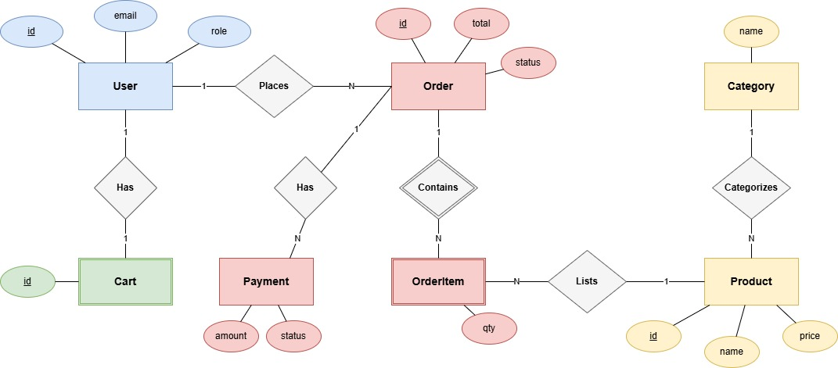

Figure 7.37: ER Diagram of Auraluxe System

## **Chapter 8.**

## **System Quality and Testing**

#### 8.1 System Quality Management

System quality management ensures that the developed Auraluxe System (Premium Building Materials E-commerce Platform) meets its functional requirements, performance expectations, and user satisfaction goals. The quality of the system was managed throughout the project by applying structured testing methods, code reviews, and continuous validation of requirements.

##### 8.1.1 Software Quality Management Process

The quality management process followed these steps:

1. **Requirement Verification:** All customer and administrator requirements (product catalog management, shopping cart operations, order processing, payment integration, content management, project portfolio display, etc.) were documented and confirmed with stakeholders before development (Mramba and Kaijage, 2018).
2. **Design Validation:** The database schema (Entity Relationship Diagram), interface design, and system architecture were validated to ensure consistency, normalization, and efficiency. The Next.js frontend and NestJS backend architecture were reviewed to ensure proper separation of concerns and RESTful API design principles.
3. **Code Quality Assurance:** Coding standards (TypeScript naming conventions, React best practices, NestJS architectural patterns, Prisma ORM conventions) were maintained and peer reviews were performed to avoid logical errors, redundancy, and maintainability issues (Pressman and Maxim, 2014). ESLint and Prettier were configured to enforce consistent code formatting across the frontend and backend.
4. **Testing:** Multiple types of testing, such as unit testing, integration testing, system testing, and user acceptance testing (UAT), were performed to verify the interaction between different modules (e.g., User Authentication, Product Catalog, Shopping Cart, Payment Processing, Content Management).
5. **Performance Evaluation:** Load testing was carried out to ensure the system could handle multiple simultaneous users browsing products, adding items to cart, and completing checkout processes without failures. Page load times and API response times were measured to ensure they met the 3-second page load and 2-second API response benchmarks.
6. **Error Monitoring Debugging:** Bugs identified during testing (e.g., cart state synchronization errors, payment callback failures, image upload issues, category filter inconsistencies) were logged, categorized by severity, and fixed before final deployment. Backend error logging and frontend error boundaries were implemented to capture and report runtime errors.
7. **User Feedback Integration:** End users (customers), admin testers, and stakeholders were involved to provide feedback on usability, which was integrated into the final version. Feedback on product browsing experience, checkout flow, and admin dashboard usability was incorporated through iterative development cycles.

##### 8.1.2 Software Test Cases

The system was tested using multiple scenarios to ensure functionality, security, and reliability. Ghezzi et al. (2002). Some key test cases are listed below:

Table 8.1: Test Cases for the System

|  |  |  |  |  |
| --- | --- | --- | --- | --- |
| **Test Case ID** | **Feature Tested** | **Input / Action** | **Expected Result** | **Status** |
| TC1 | User Registration | Enter new name, email, password | New user account created, verification email sent, confirmation message shown | Passed |
| TC2 | User Login | Enter valid email and password | User authenticated, redirected to home page or dashboard based on role | Passed |
| TC3 | Invalid Login | Enter wrong password or unregistered email | Error message displayed ("Invalid credentials") | Passed |
| TC4 | Browse Products | Navigate to product listing page, view products | Product grid displays with images, names, prices, and categories | Passed |
| TC5 | Search Products | Enter product keyword in search bar (e.g., "tiles") | Filtered products matching keyword displayed | Passed |
| TC6 | Filter by Category | Select category filter (e.g., "Lighting") | Only products from selected category displayed | Passed |
| TC7 | Filter by Brand | Select brand filter (e.g., specific brand name) | Only products from selected brand displayed | Passed |
| TC8 | View Product Details | Click on product card | Product detail page loads with full specifications, features, description, and images | Passed |
| TC9 | Add to Cart | Click "Add to Cart" on product detail page while logged in | Product added to cart, cart counter updates, success message displayed | Passed |
| TC10 | Add to Cart (Not Logged In) | Click "Add to Cart" without logging in | User redirected to login page | Passed |
| TC11 | Update Cart Quantity | Change quantity in cart, click update | Cart item quantity updated, subtotal recalculated | Passed |
| TC12 | Remove from Cart | Click remove/delete icon on cart item | Item removed from cart, cart total updated | Passed |
| TC13 | Cart Persistence | Add items to cart, logout, login again | Cart items persist and display correctly | Passed |
| TC14 | Checkout Process | Click "Proceed to Checkout" with items in cart | Checkout page loads with order summary and form fields | Passed |
| TC15 | Payment Gateway | Complete checkout and process payment using SSLCommerz sandbox | Payment successful, validation ID received, order status updates to "Paid" | Passed |
| TC16 | Payment Failure | Cancel payment or use invalid card in SSLCommerz | Order remains "Pending Payment", user returned to checkout with error message | Passed |
| TC17 | Order Confirmation | Successfully complete payment | Order confirmation page displayed, confirmation email sent, order appears in order history | Passed |
| TC18 | View Order History | Navigate to "My Orders" section | List of user's orders displayed with status, date, and total | Passed |
| TC19 | Admin - Create Product | Admin creates new product with all required fields, uploads image | Product created successfully, appears in product catalog | Passed |
| TC20 | Admin - Edit Product | Admin updates product price and description | Product details updated in database and frontend | Passed |
| TC21 | Admin - Delete Product | Admin soft-deletes product | Product marked as deleted (isDeleted=true), hidden from frontend | Passed |
| TC22 | Admin - Manage Categories | Admin creates new category | Category created and available for product assignment | Passed |
| TC23 | Admin - Manage Brands | Admin creates new brand with logo | Brand created with logo uploaded successfully | Passed |
| TC24 | Admin - Manage Home Banners | Admin adds new banner with image and sets display order | Banner appears on home page in specified order | Passed |
| TC25 | Admin - Create Project | Admin creates project portfolio entry with details, images, social media links | Project created and displays on projects page | Passed |
| TC26 | Inventory Management | Admin updates product quantity to 0 | Product shows "Out of Stock" on frontend, cannot be added to cart | Passed |
| TC27 | System Load Test | 100 users browse products and add to cart simultaneously | System remains stable with no downtime; pages load within acceptable time | Passed |
| TC28 | Security Test (SQL Injection) | Try inserting malicious SQL in search, login, or form fields | System blocks attempt, sanitizes input, and shows generic error | Passed |
| TC29 | Security Test (XSS) | Try injecting JavaScript in product search or review forms | Input sanitized, script not executed, safe text displayed | Passed |
| TC30 | Session Management | User logs out and presses back button | Session expired, requires re-login to access secured pages | Passed |
| TC31 | Role-Based Access | Regular user tries to access admin routes directly | Access denied, user redirected to unauthorized page | Passed |
| TC32 | Responsive Design | Access website on mobile, tablet, and desktop | UI adapts correctly to different screen sizes, all features functional | Passed |
| TC33 | Image Upload (Admin) | Admin uploads product image larger than 5MB | System rejects upload with error message about file size limit | Passed |
| TC34 | Form Validation | Submit registration form with invalid email format | Form validation error displayed, submission blocked | Passed |
| TC35 | Empty Cart Checkout | Attempt to checkout with empty cart | User prevented from proceeding, message to add items displayed | Passed |

## **Chapter 9.**

## **Ethical Consideration**

#### 9.1 Ethical Considerations in the Software Development Process

Developing the Auraluxe platform involved navigating complex ethical landscapes, particularly given its nature as an e-commerce platform handling financial transactions and customer data for premium building materials.

**1. Data Privacy and Security**

In an e-commerce marketplace, protecting user privacy is paramount. The system handles highly sensitive Personally Identifiable Information (PII), including customer names, email addresses, phone numbers, delivery addresses, and payment transaction data. To ensure confidentiality and compliance with data protection standards:

* E**ncryption:** Passwords are hashed using industry-standard bcrypt algorithms before storage. All data in transit is encrypted via HTTPS/TLS protocols.
* **Access Control:** Strict Role-Based Access Control (RBAC) ensures that only authorized Admins can access user data, manage products, and view order details. Regular users can only access their own cart, orders, and profile information.
* **Payment Security:** Financial data is never stored locally. The integration with SSLCommerz ensures that sensitive card details are handled by a PCI-DSS compliant payment gateway. The system only stores transaction references and order status, not actual payment credentials.
* **Data Minimization:** The system only collects data necessary for order fulfillment and customer communication. Optional fields are clearly marked, and users maintain control over their personal information. Sommerville (2016) Turban and Volonino (2010)

**2. Intellectual Property**

The development of Auraluxe respected all intellectual property rights. The solution utilizes open-source technologies such as Next.js, React, NestJS, Node.js, PostgreSQL, and Prisma ORM, adhering strictly to their MIT or Apache 2.0 licenses. External services like SSLCommerz payment gateway were integrated according to their Terms of Service, ensuring proper attribution and usage compliance. The core business logic, database schema, custom UI components, and product content remain the intellectual property of the development team and Tilottoma organization. Bass et al. (2012) Ghezzi et al. (2002)

**3. User Impact**

The system significantly impacts the experience of customers seeking premium building materials and interior solutions. For customers, the platform provides convenient access to high-quality imported products with detailed specifications, eliminating the need for multiple showroom visits. For the business, it creates a digital presence that reaches customers beyond physical location constraints. The design prioritizes "User Trust"—features like secure payment processing, detailed product information, and transparent pricing were implemented to build confidence. Accessibility best practices were followed in the UI design to ensure the platform is usable by users of varying technical abilities and across different devices. Sommerville (2011b) Sommerville (2011a)

**4. Bias and Fairness**

 Auraluxe is designed to be an equitable platform that serves all customers fairly.

* **Algorithm Neutrality:** Product search and filtering algorithms are based solely on user-selected criteria (category, brand, price range, keywords) without hidden ranking manipulations. Products are displayed based on relevance to search terms and filter selections, ensuring fair product visibility.
* **Content Integrity:** All product descriptions, specifications, and pricing information are accurate and verifiable. The platform does not engage in misleading advertising or deceptive pricing practices.
* **Fair Access:** The platform is accessible to all users regardless of their geographic location within Bangladesh, device type, or technical proficiency. The responsive design ensures equal user experience across desktop, tablet, and mobile devices. Hevner and Chatterjee (2010)

**5. Responsibility to Stakeholders**

The primary stakeholders are Customers, Business Administrators, and the Tilottoma Organization.

* **Customers:** The team is responsible for delivering a secure, reliable shopping experience where orders are processed accurately, payments are protected, and products are represented truthfully.
* **Business Administrators:** The system must provide accurate inventory tracking, sales reporting, and order management to support effective business operations and decision-making.
* **Organization:** The platform must protect the brand reputation by ensuring data security, maintaining system uptime, and providing quality customer experience. Regular testing and quality assurance processes helped align the software functionality with these stakeholder needs. Hevner and Chatterjee (2010)

**6. Professional Responsibility**

The development team adhered to the ACM/IEEE Software Engineering Code of Ethics. This specifically meant:

* **Honesty:** Clearly communicating system capabilities and limitations, such as payment gateway processing times and inventory update frequencies.
* **Competence:** Ensuring the payment integration and data security modules were implemented using industry-standard best practices to prevent financial loss and data breaches. Following established design patterns and architectural principles in Next.js and NestJS development.
* **Maintenance:** Committing to resolving critical bugs (like payment callback failures or cart synchronization issues) promptly to prevent customer disruption and business loss. Hevner and Chatterjee (2010)

#### 9.2 Sustainability in the Software Development Process

Sustainability is integrated into the core architecture of Auraluxe, addressing environmental, economic, and social dimensions.

**1. Environmental Sustainability**

* **Paperless Workflow:** By digitizing the entire shopping and ordering process—from product browsing to digital receipts and invoices—Auraluxe significantly reduces paper waste involved in traditional catalog distribution, order forms, and billing processes.
* **Digital Catalog:** The online product catalog eliminates the need for printed catalogs, brochures, and promotional materials, reducing paper consumption and distribution-related carbon emissions.
* **Server Optimization:** Database queries are optimized using Prisma ORM's efficient query generation to fetch only necessary data, reducing CPU cycles and energy consumption in data centers. Frontend code splitting and image optimization in Next.js minimize bandwidth usage and reduce energy consumption on user devices.
* **Reduced Physical Travel:** By providing comprehensive product information, specifications, and images online, customers can make informed decisions without multiple showroom visits, reducing transportation-related carbon emissions.

**2. Economic Sustainability**

* **Digital Transformation:** The platform enables Tilottoma to reach customers beyond physical showroom constraints, supporting business growth and economic viability.
* **Cost Efficiency:** Online presence reduces traditional advertising costs, while automated order processing and inventory management minimize operational overhead.
* **Scalability:** The modular Next.js and NestJS architecture allows the system to handle increased traffic and expand product categories without redevelopment, ensuring long-term software investment value. Pressman and Maxim (2014).
* **Market Accessibility:** The platform reduces geographic barriers for customers accessing premium building materials.

**3. Social Sustainability**

* Information Access: By providing detailed specifications and project portfolios, the platform democratizes access to premium building materials information previously limited to showroom consultations.
* Digital Literacy: The user-friendly interface helps users of varying technical abilities engage with e-commerce, advancing digital literacy in the building materials sector.
* Quality Standards: By showcasing verified, premium products with transparent specifications, the platform raises quality standards in the market, benefiting end consumers and construction quality.
* Business Growth: The platform supports Tilottoma's growth as a local business, contributing to employment and economic activity in the community. Turban and Volonino (2010).

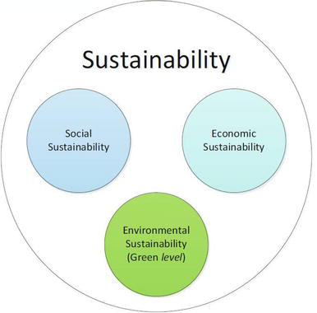

Figure 9.1: Sustainability Considerations in Software Development

## **Chapter 10.**

## **Conclusion**

#### 10.1 Brief Overview of the Project

The **Auraluxe** system was designed to provide a comprehensive digital showroom for high-end building materials and interior solutions. It serves as a modern bridge between architectural inspiration and material acquisition, replacing the traditional, time-consuming process of physical showroom visits with a centralized, visual-first online platform. By introducing features such as a "Project Inspiration" showcase, detailed product specification filtering, seamless cart management, and secure digital payments, the project aims to digitize the luxury home improvement sector. On the administrative side, the system offers robust tools for inventory management and order fulfillment, ensuring an efficient operational flow for the business.

#### 10.2 Proposed System Benefits

The developed system offers a range of benefits for both Customers and the Business Administration:

1. **Visual Decision Making:** Unlike standard e-commerce sites, the "Project Inspiration" feature allows users to see completed real-world projects and immediately identify/buy the materials used, bridging the gap between design and purchase.
2. **Digital Showroom Experience:** Users can browse high-resolution catalogs of luxury tiles and sanitary ware from the comfort of their homes, filtering by Brand, Finish, or Price.
3. **Operational Efficiency:** The Admin Dashboard automates stock tracking and order status updates, reducing the manual effort required to manage a large inventory of distinct SKUs.
4. **Secure Transactions:** Integration with **SSLCommerz** provides a regulated and secure environment for high-value financial exchanges, minimizing fraud risk and building customer trust.
5. **Performance & SEO:** Built on **Next.js**, the platform utilizes Server-Side Rendering (SSR) to ensure fast load times and better search engine visibility, critical for capturing organic traffic.
6. **Data Integrity:** The use of **Prisma ORM** ensures strict data consistency, preventing errors like selling out-of-stock items or orphaning project details.

#### 10.3 Limitations of the Project

While the system meets its primary objectives, several limitations remain, which highlight areas for improvement:

1. **Lack of AR Visualization:** The current system allows viewing static images, but lacks Augmented Reality (AR) features to help users visualize how a tile or fitting would look in their actual space.
2. **Internet Dependence:** As a cloud-hosted web application, it requires a stable high-speed internet connection to load high-resolution textures and project images, which may be slow on weaker networks.
3. **Payment Gateway Sandbox:** The current implementation uses the SSLCommerz Sandbox environment; a live production deployment would require business verification and merchant API activation.
4. **Lack of Native Mobile App:** The system is a Responsive Web App (RWA), which lacks native mobile features like push notifications for order delivery updates.
5. **No Live Sales Support:** Communication is currently asynchronous (via contact forms); a real-time chat widget for immediate consultation with sales representatives is missing.
6. **Single-Vendor Constraint:** The architecture is currently designed for a single brand/storefront and would require significant refactoring to support a multi-vendor marketplace model.

These limitations emphasize that while the project demonstrates strong architectural principles and functional value, further refinement is needed for a commercial-grade launch.

#### 10.4 Practicum and Its Value

The practicum offered meaningful real-world learning opportunities by connecting theoretical knowledge with practical application. The experience included:

1. **Technical Mastery:** Deepened expertise in the **MERN Stack** (specifically **Next.js** for frontend and **NestJS** for backend) and modern ORM tools like **Prisma**.
2. **Third-Party Integration:** Gained practical experience integrating diverse external services such as **SSLCommerz** (FinTech) for payments and potentially Cloudinary for image optimization.
3. **Complex Logic Implementation:** Solved challenging problems related to relational data modeling—specifically linking "Inspiration Projects" to "Raw Materials" and managing inventory concurrency during checkout.
4. **Professional Development:** Reinforced the importance of code reviews, strict typing with **TypeScript**, and adhering to modular project structures. Overall, the practicum bridged the gap between academic concepts and industry-standard software engineering practices.

#### 10.5 Future Plan

Future development of the system will focus on addressing the identified limitations and preparing it for larger-scale deployment. Planned improvements include:

1. **Native Mobile Application:** Developing cross-platform apps (using .NET MAUI or React Native) to leverage native push notifications and background location tracking.
2. **Real-Time Chat Module:** Implementing a WebSocket-based (SignalR) chat system to allow users and providers to communicate instantly within the app.
3. **Advanced Recommendation Engine:** Using Machine Learning to suggest services to users based on their past booking history and search patterns.
4. **Multiple Payment Options:** Expanding beyond SSLCommerz to include bKash, Nagad, and Stripe APIs for broader payment accessibility.
5. **Infrastructure Scalability:** Migrating the monolithic architecture to microservices (separating Auth, Booking, and Notification services) to handle thousands of concurrent users.
6. **Enhanced AI Features:** Implementing image recognition to automatically categorize portfolio photos uploaded by providers.

These enhancements will help transition Neighbourly from a functional prototype to a market-ready platform capable of serving a city-wide user base.

Future development of the system will focus on addressing the identified limitations and preparing it for larger-scale deployment. Planned improvements include:

1. **Augmented Reality (AR) View:** Implementing a "View in Room" feature using WebXR, allowing customers to use their phone camera to visualize tiles on their floors before buying.
2. **Live Chat Module:** Integration of a real-time support widget (like WhatsApp Business API or Tawk.to) to allow instant communication between architects/homeowners and sales staff.
3. **AI Design Assistant:** Using Machine Learning to suggest matching products (e.g., suggesting a specific basin that matches the selected floor tiles).
4. **Multi-Warehouse Support:** expanding the database schema to track stock levels across multiple physical showroom locations.
5. **Dynamic Shipping Calculation:** Integration with logistics APIs (like Pathao or RedX) to automatically calculate shipping costs based on the weight of heavy materials like stone or tiles.

These enhancements will help transition **Auraluxe** from a functional prototype to a market-leading digital platform in the luxury building materials sector.

## **References**

NestJS (2025). Documentation | NestJS - A progressive Node.js framework. [online] Available at: https://docs.nestjs.com/.

Vercel (2025). Next.js Documentation - The React Framework for the Web. [online] Nextjs.org. Available at: https://nextjs.org/docs.

Prisma (2025). Prisma | Next-generation ORM for Node.js & TypeScript. [online] Available at: https://www.prisma.io/docs.

SSLCommerz (2024). SSLCommerz Payment Gateway API Documentation. [online] Developer.sslcommerz.com. Available at: https://developer.sslcommerz.com/doc/v4/.

Kamil Myśliwiec (2023). NestJS: The Progressive Node.js Framework. [online] Medium. Available at: https://kamilmysliwiec.com/nest-release-v10.

Fortune Business Insights (2024). Furniture Market Size, Share & COVID-19 Impact Analysis | Global Forecast [2030]. [online] Fortunebusinessinsights.com.

Martin, R. C. (2017). Clean Architecture: A Craftsman's Guide to Software Structure and Design. Prentice Hall.

Khalil, S. (2023). Decoupling Logic with Modular Architecture in NestJS. [online] Dev.to. Available at: https://dev.to/khalil/modular-architecture-in-nestjs.

TanStack (2024). TanStack Query (React Query) Documentation. [online] Available at: https://tanstack.com/query/latest.

Pressman, R. S. and Maxim, B. R. (2014), Software Engineering: A Practitioner’s Approach, 8th edn, McGraw-Hill Education, New York.

Sommerville, I. (2016), Software Engineering, 10th edn, Pearson, Boston.

Bass, L., Clements, P. and Kazman, R. (2012), Software Architecture in Practice, 3rd edn, Addison-Wesley, Boston.

Turban, E. and Volonino, L. (2010), Information Technology for Management, 7th edn, John Wiley & Sons, Hoboken.

PostgreSQL (2025). PostgreSQL: The World's Most Advanced Open Source Relational Database. [online] Available at: https://www.postgresql.org/docs/.